

**SWP391 PROJECT REPORT**

**Software Requirement Specification**

– Da Nang, July 2023 –

* **DOCUMENT HISTORY**

|  |  |  |
| --- | --- | --- |
| **Date** | **Summary of Changes** | **Version** |
| 26-05-2023 | * Draw a general Use Case diagram and assign work. * Describe the framework of the report and outline some of the functions. | 1.0 |
| 30-05-2023 | * Draw mockups for Guest and User pages | 1.0 |
| 01-06-2023 | * Draw mockup for Manager page | 1.0 |
| 02-06-2003 | * Create detailed Use Case for Guest and User | 1.0 |
| 03-06-2023 | * Fixed some errors in the User's Room Rental Registration * Edit mockup for Guest page | 1.0 |
| 05-06-2003 | * Create detailed Use Case for Manager | 1.0 |
| 06-06-2023 | * Fixed some bugs in the Manager's Add, Edit, Delete Room | 1.0 |
| 08-06-2023 | * Add function Request to change room missed by User and Manager | 1.0 |
| 10-06-2023 | * Fixed some errors in the Account Registration section | 1.0 |
| 12-06-2023 | * Edit and finalize mockups. * Finalize the report | 1.0 |
| 15-06-2023 | * Fixed some mockups with typos | 1.0 |
| 17-06-2023 | * Fixing non-standard Use Case diagrams |  |
| 18-06-2023 | * Edit and finalize the report | 1.0 |
| 29-06-2023 | * Added error messages “Vượt giới hạn ký tự tối đa!” | 2.0 |
| 03-07-2023 | * Add Paging and Back to Room Search screen | 2.0 |
| 07-07-2023 | * Add asterisks * for Required items | 2.0 |
| 09-07-2023 | * •Edit and finalize the report | 2.0 |

* **REFERENCE DOCUMENTS**

|  |  |
| --- | --- |
| **Document Name** | **Description** |
| Template_SRS.docx | As a document of the GVHD FSOFT team, the content inside includes how to fully report the RMS model. |
|  |  |

* **DISTRIBUTION LIST AND APPROVALS**

|  |  |
| --- | --- |
| **Name** | **Title** |
| Nguyễn Văn Tân | Create Usecases for the Guest section.  Write the SRS document for the Guest section. |
| Ngô Hải Thy | Create Usecases for the User section.  Write the SRS document for the User section. |
| Phạm Ngọc Hùng | Create Usecases for the User section.  Write the SRS document for the User section. |
| Đinh Trọng Hải Triều | Create Usecases for the Manager section.  Write SRS documents for the Manager. |
| Ngô Hồ Gia Kiệt | Create Usecases for the Manager section.  Write SRS documents for the Manager. |

* **INTRODUCTION**
* ***Purpose***

The purpose of this document is to describe in detail the functions of “Xây dựng Hệ thống quản lý sinh viên lưu trú (nhận, trả phòng) tại KTX Trường Đại học FU". It illustrates the functionality in detail, builds a complete system, clearly explains the system's constraints and gives an overview of the interface and interactions with the system or other external applications. This document uses the description presented to the customer for better editing and adjustment.

* ***In scope***.
* Nowadays, with the increasing number of students each year studying at FU University, the issue of student accommodation management is one of the urgent issues. In fact, most accommodation management is only managed on papers manually, which is time consuming and easily lead to errors.

The application of technology in the management of the dormitory is really necessary to make the management easier, avoid data loss, process information not only quickly, efficiently but also with high accuracy and highly accurate, saving time and effort of administrators as well as enhancing the overall student experience. Our team proposes to develop a Student Dormitory Management System at FU University to solve these problems and provide a more streamlined approach to the management of student dormitories with the desire to apply technology to dormitory management.

* The system serves 3 main actors:

+ Guest

+ User (Students of FTP University)

+ Manager (Officers of the Dormitory Management)

The dormitory management system will help students register room and pay for their bills quickly and easily. The system will also make it easier and time-saving to manage room allocation, room registration as well as store and process information about students and configuration in the dormitory.

* **OVERVIEW**
* ***Actors***

The table below depicts all the actors involved in “Xây dựng Hệ thống quản lý sinh viên lưu trú (nhận, trả phòng) tại KTX Trường Đại học FU". Each actor will have a different role in the system; Currently we have actors: Guest, User, Manager. Guest has the right to view information about the dormitory and register an account for the system if they are a student of FU University, they do not have their own accounts. Users have the right to view the existing rooms in the dormitory, register to rent a room, change rooms, pay bills (room rental/electricity/water) of the dormitory, send requests and complaints to the Managers, manage their personal account. Manager has the right to manage notifications on the homepage, create, edit, delete room information, manage room rental requests, manage invoices, view and respond to requests, complaints, view statistics of the dormitory, personal account management, information management, accounts of students.

|  |  |
| --- | --- |
| **Actor** | **Description** |
| Guest | Have the right to view information about the dormitory.  Have the right to register an account if they are students of FPT University and do not have their own account yet. |
| User | Have permission to view available rooms in the dormitory.  Have the right to register to rent rooms, change rooms.  Have the right to pay the bills (room rental/electricity) of the dormitory.  Have the right to send requests and complaints to the Management Board.  Have the right to manage their personal accounts. |
| Manager | Have the right to manage the notices on the homepage.  Have the right to create, edit, delete room information, manage room rental requests.  Have the right to manage all kinds of invoices.  Have the right to view and respond to requests and complaints.  Have the right to view the dorm's statistics.  Have the right to manage personal accounts.  Have the right to manage information and accounts of students. |

* ***System Use Case Diagram***

Sơ dồ sau đây cung cấp một cái nhìn tổng quan về các nhóm chức năng, tác nhân tham gia vào *Xây dựng Hệ thống quản lý sinh viên lưu trú (nhận, trả phòng) tại KTX Trường Đại học FU*

*The following diagram provides an overview of the functional groups and actors involved in the development of the "Xây dựng Hệ thống quản lý sinh viên lưu trú (nhận, trả phòng) tại KTX Trường Đại học FU".*

* ***Guest***
* ***Xem thông tin về trang web***

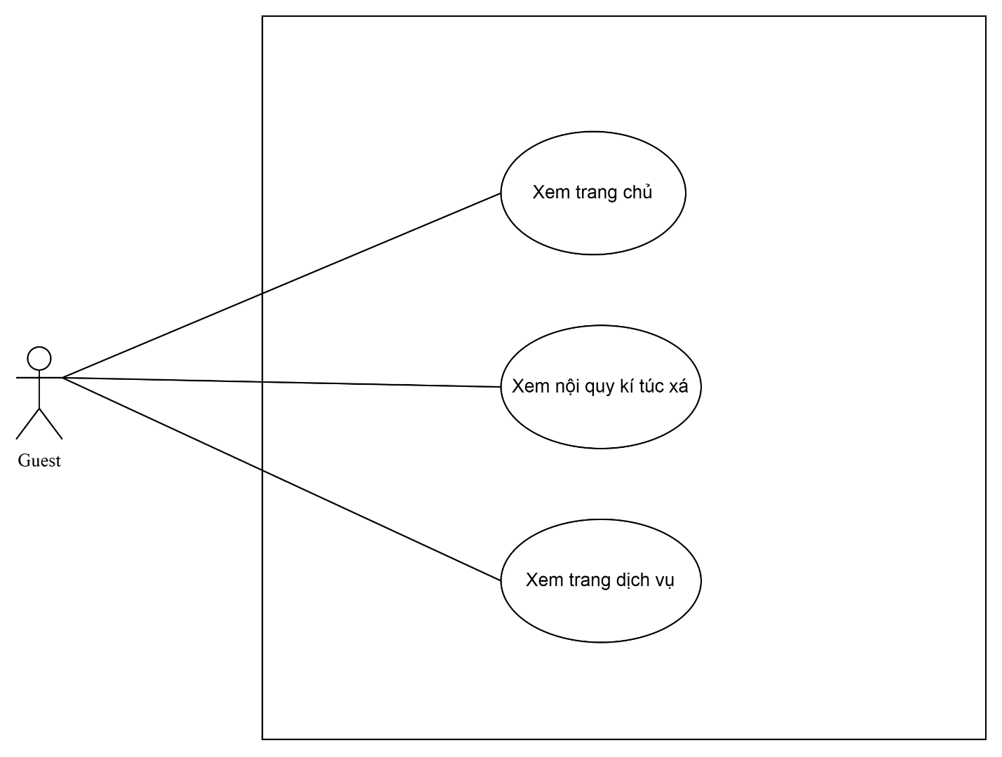

* ***Account register***

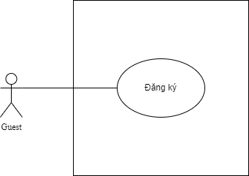

* ***User***
* ***View information of website***

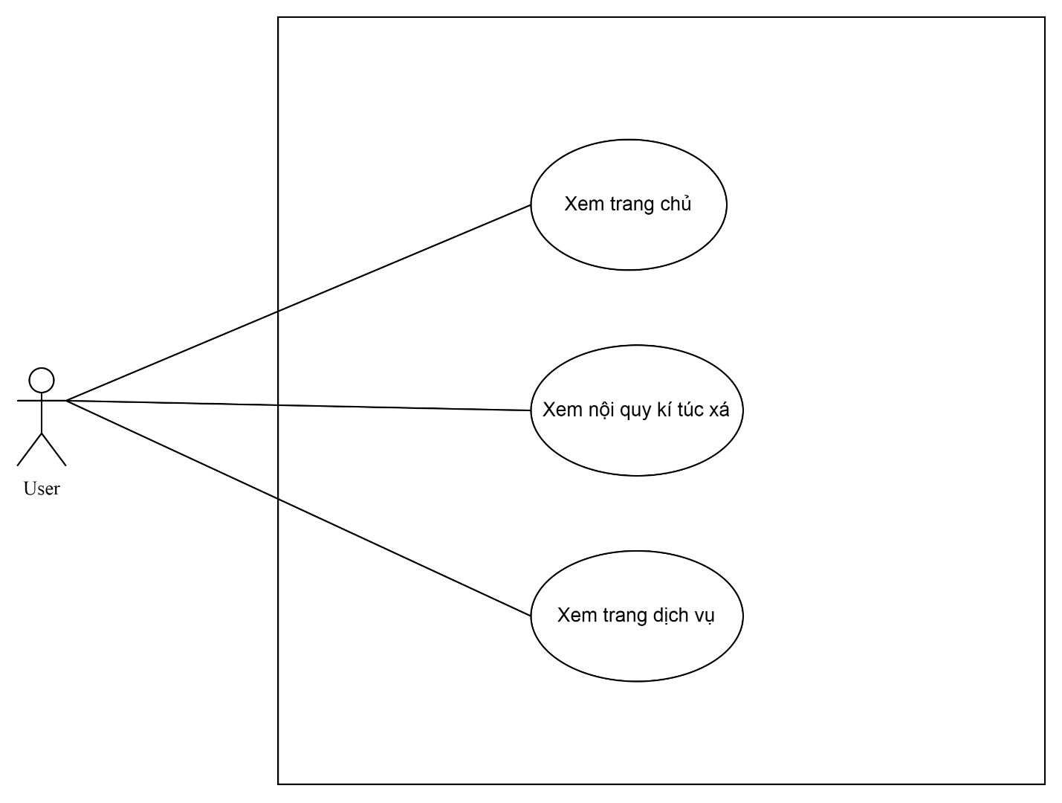

* ***Verifying account***

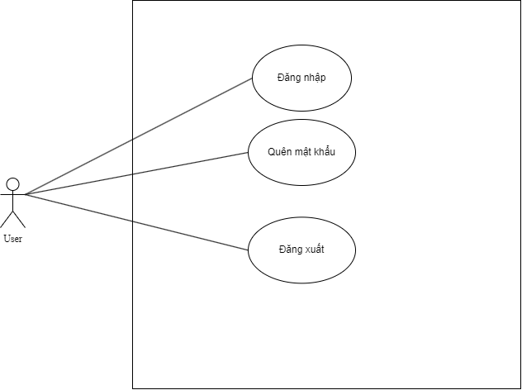

* ***Managing profile***

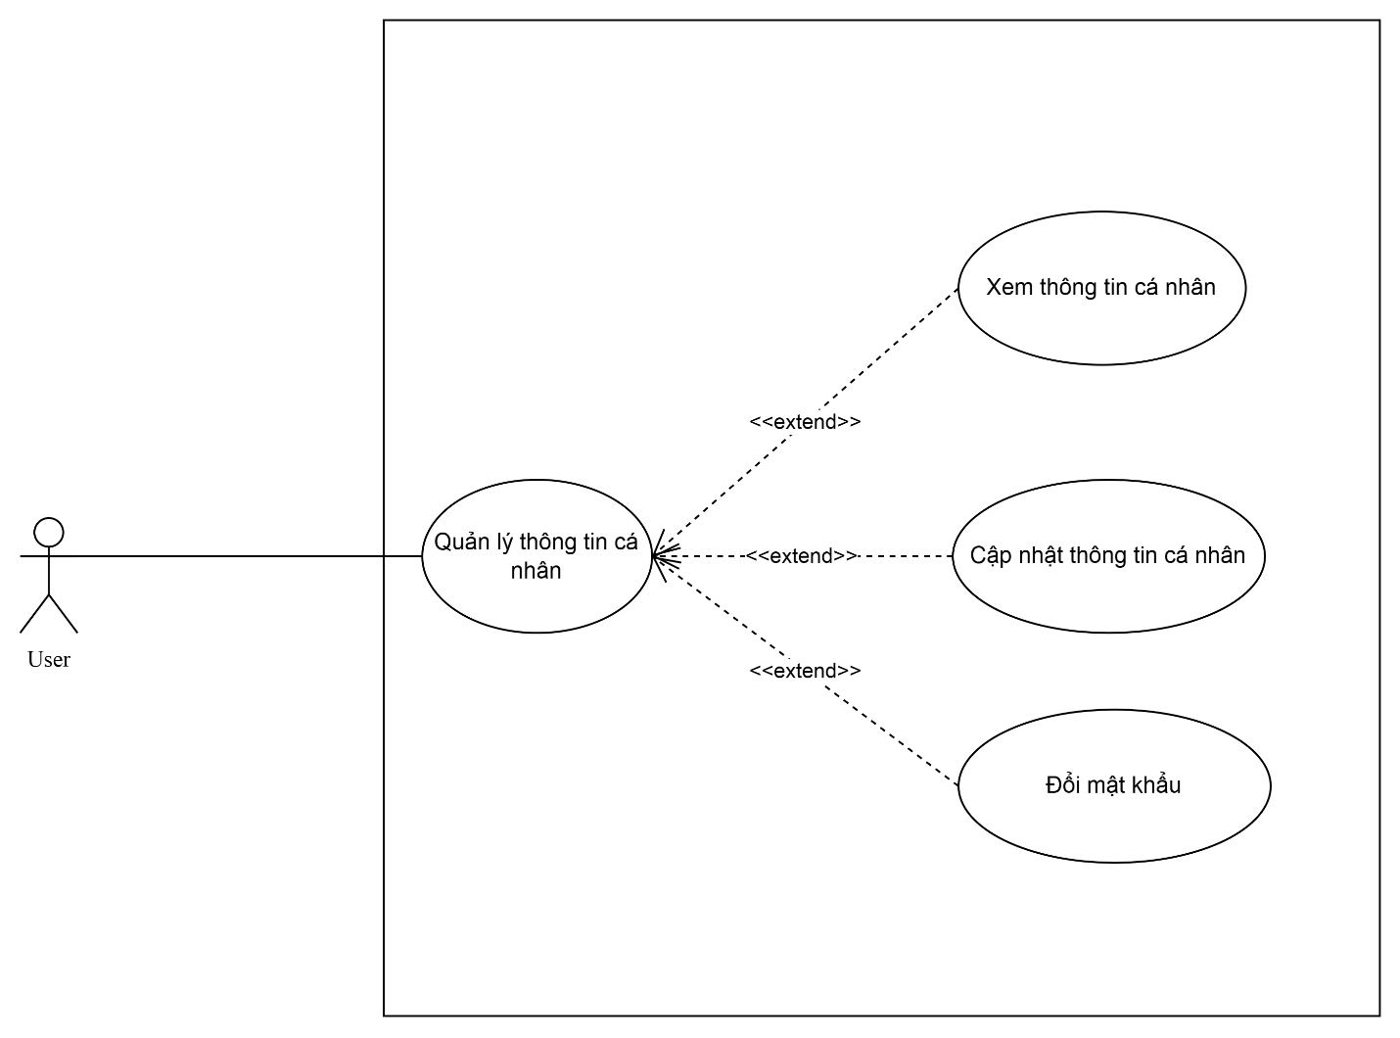

* ***Room searching***

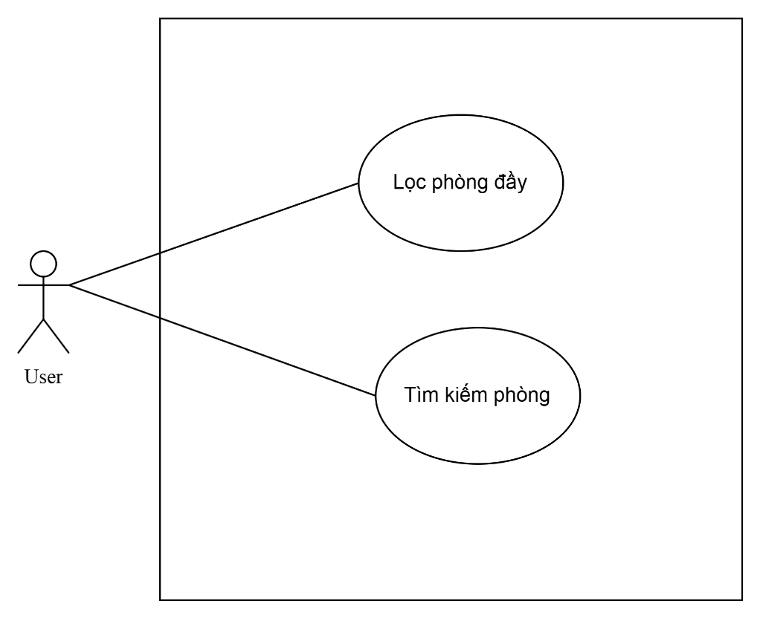

* ***Room renting***

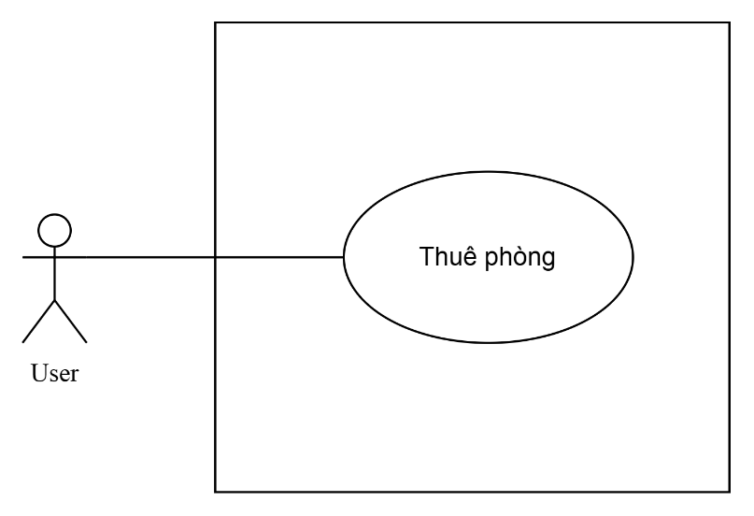

* ***Payment***

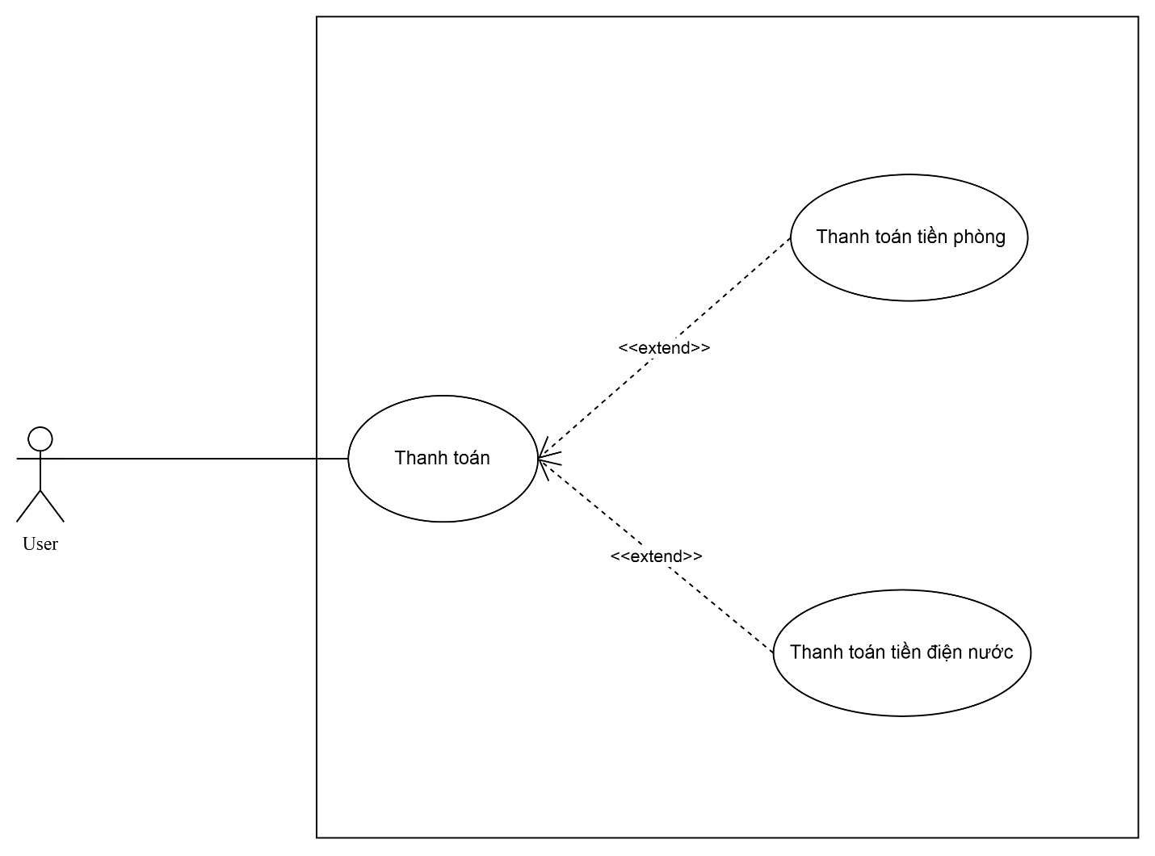

* ***Sending request and complaints***

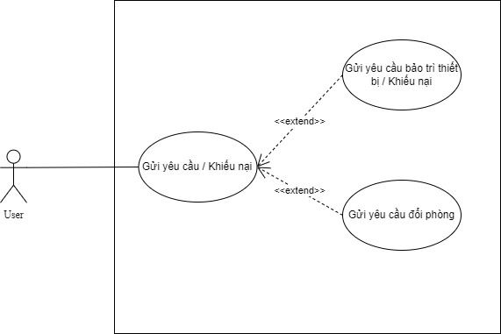

* ***Viewing information of roomates***

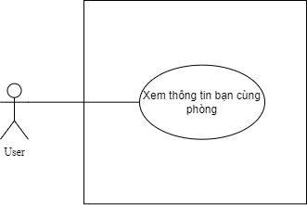

* ***Manager***
* ***Viewing information of website***

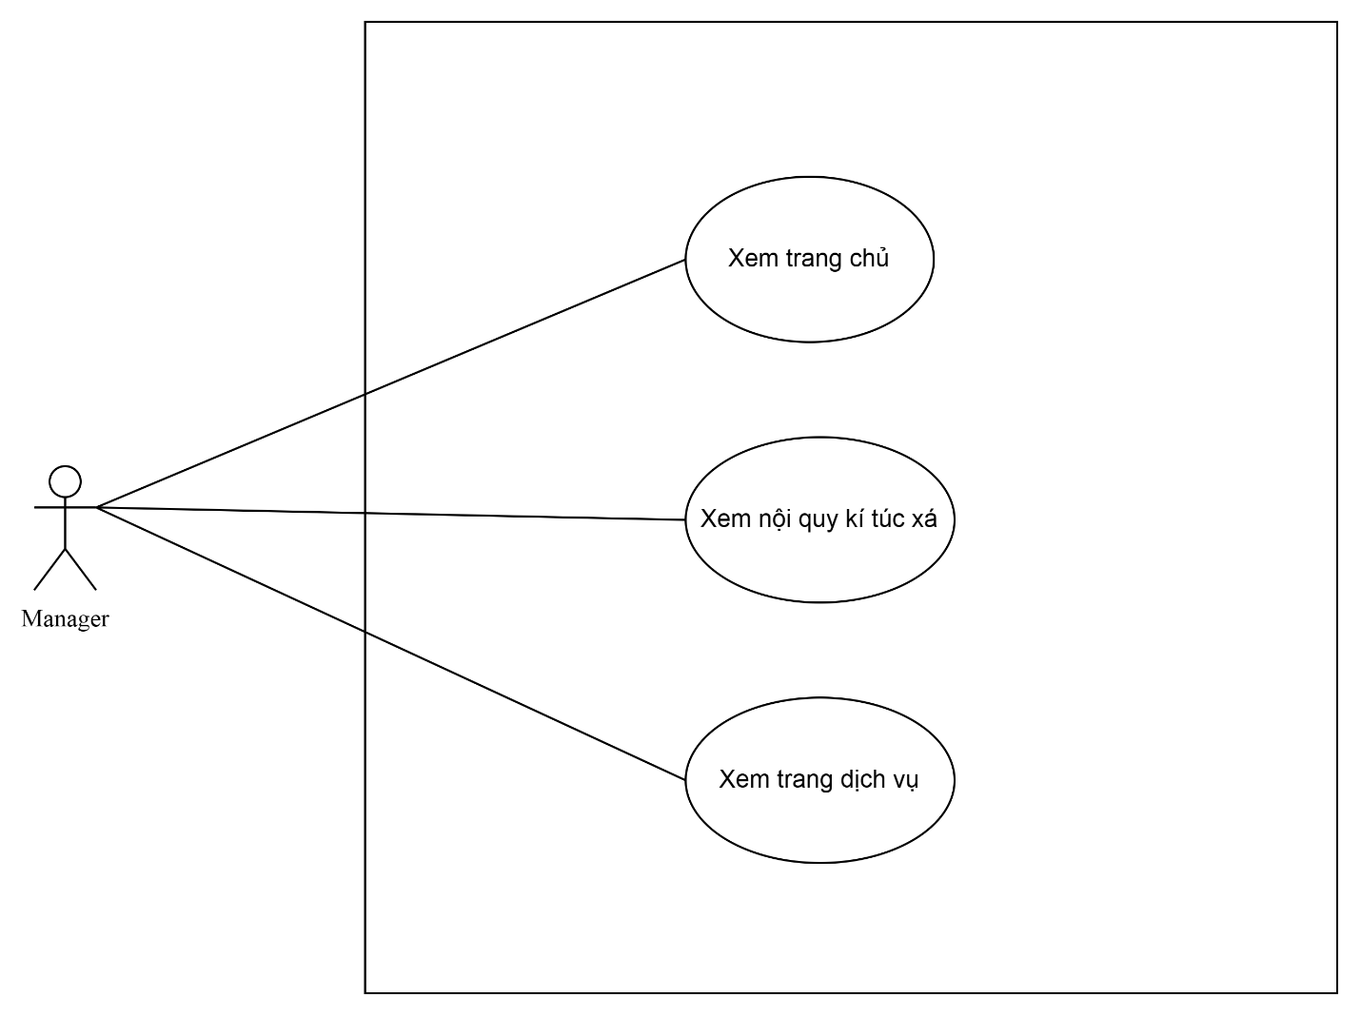

* ***Verifying account***

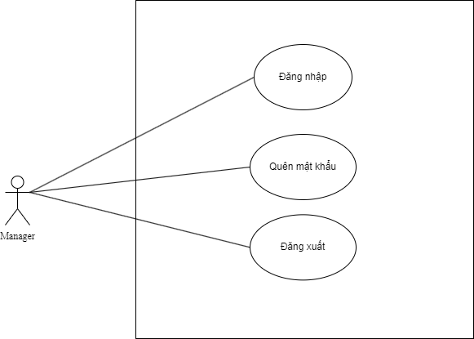

* ***Managing profile***

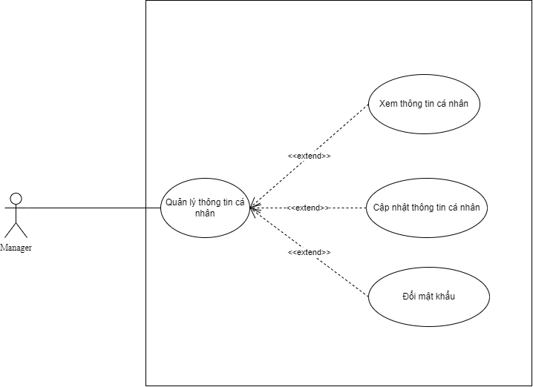

* ***Managing notifications***

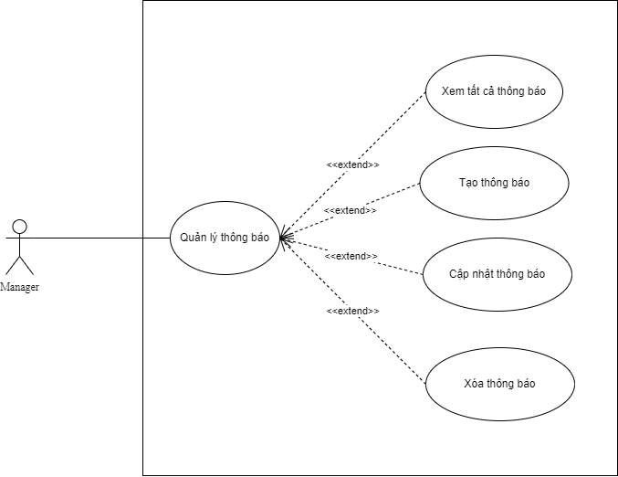

* ***Managing room renting***

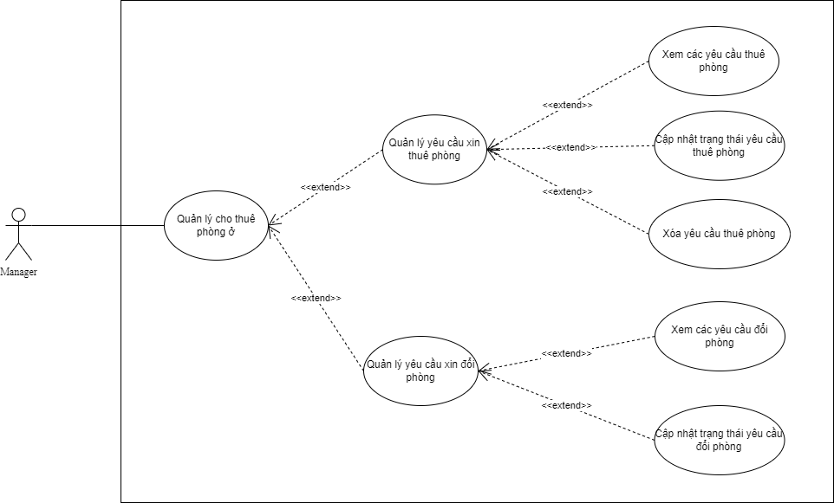

* ***Managing students' information***

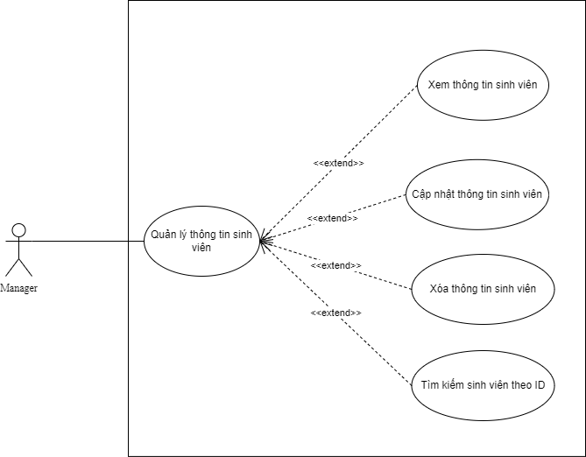

* ***Managing rooms' information***

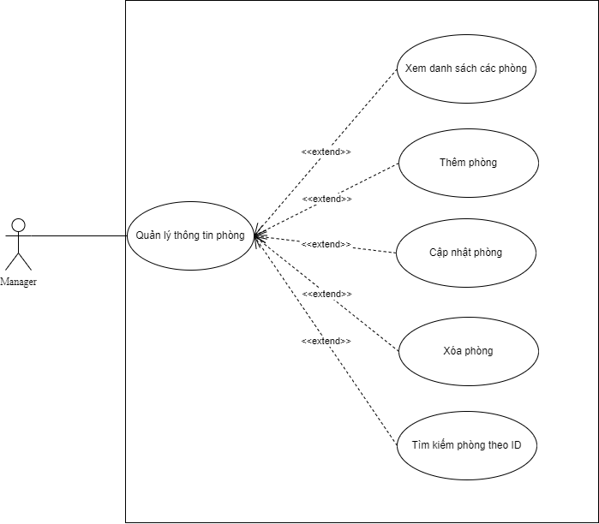

* ***Managing payment***

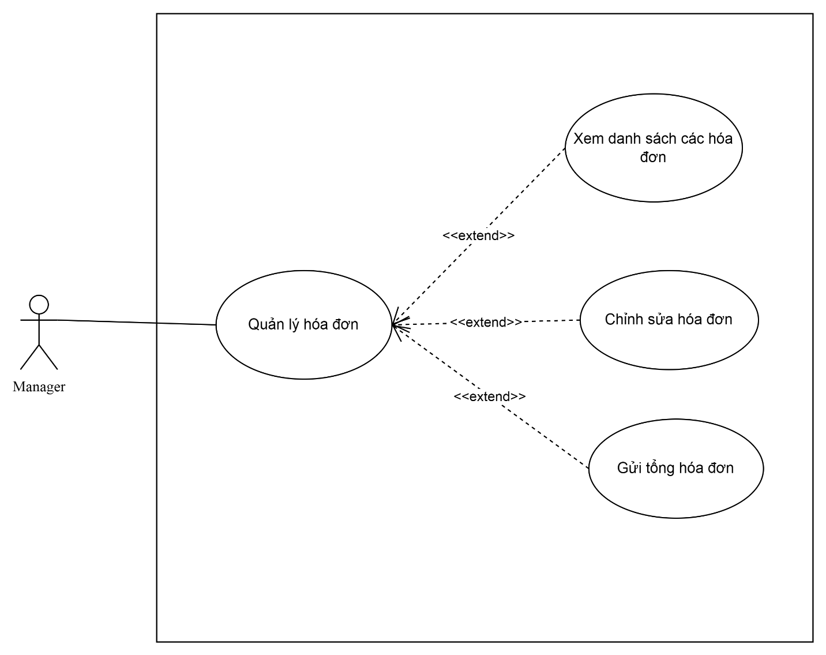

* ***Managing request and complaints***

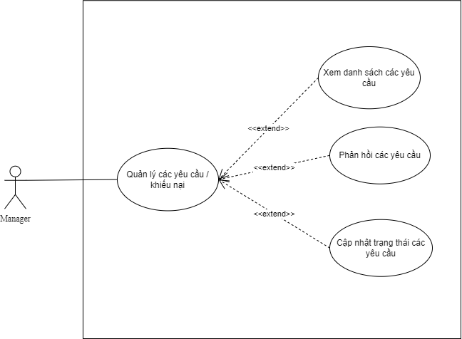

* ***Statistics***

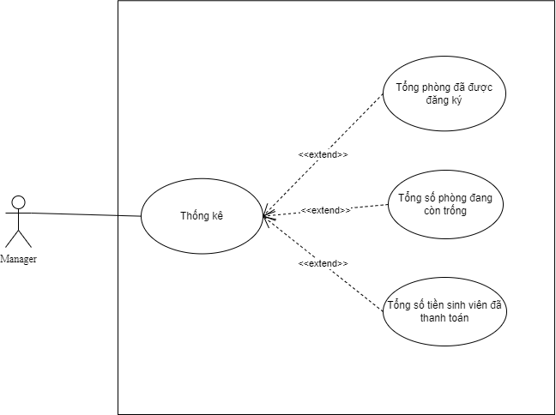

* **FUNCTIONAL DESCRIPTION**
* ***Guest***
* ***Viewing information of website***

|  |  |
| --- | --- |
| Use Case Name | Viewing information of website |
| Use Case ID | UC01 |
| High Level Requirement Ref | Medium |
| Actor | Guest |
| Description | Allows Guest to view information on the website such as the homepage, notifications, dormitory rules and dormitory services. |
| Trigger | N/A |
| Pre-condition | Guest accesses web address of the dormitory management system |
| Post-processing |  |

* ***Viewing homepage and notifications***

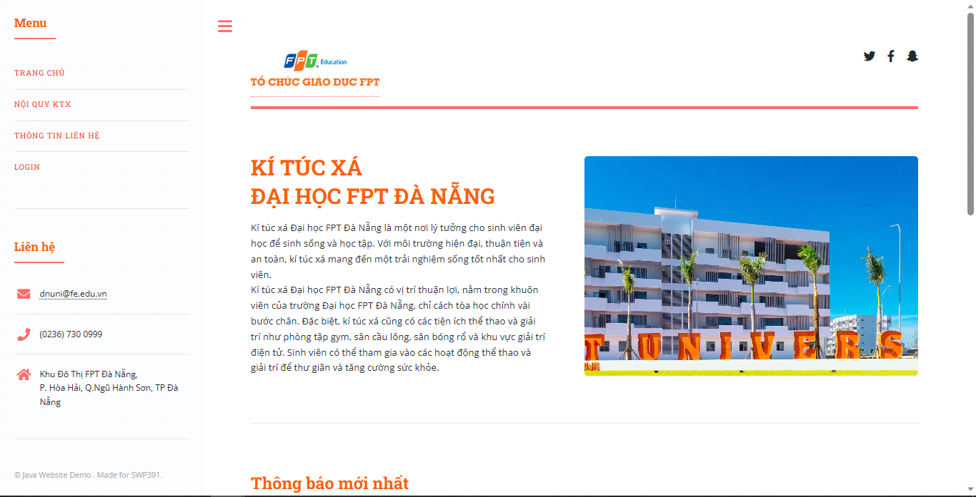

|  |  |  |  |  |  |  |  |
| --- | --- | --- | --- | --- | --- | --- | --- |
| **Screen** | ***Viewing homepage and notifications*** | | | | | | |
| **Description** | | | The system's homepage | | | | |
| **Screen Access** | | | Guest accesses web address of the dormitory management system | | | | |
| **Screen Content** | | | | | | | |
| **Item** | | | **Type** | | **Data** | | **Description** |
| Ki Túc Xá Đại Học FPT Đà Nẵng | | | Label – String (1000) | |  | | Overview about FU dormitory. |
| Thông báo mới nhất | | | Label – String (500) | |  | | View 2 latest news from managers. |
| Xem tất cả thông báo | | | Button | |  | | Click to view the list of all news posted by managers. |
| **Screen Actions** | | | | | | | |
| **Action Name** | | **Description** | | **Success** | | **Failure** | |
| Xem tất cả thông báo | | When Guest clicks on the **Xem tất cả thông báo**, the Guest will be redirected to a list of all news posted in the past. | | Navigate to the News list screen. | | When there is a database connection error => Display the message "Lỗi kết nối cơ sở dữ liệu”. | |

* ***Viewing dormitory's rules***

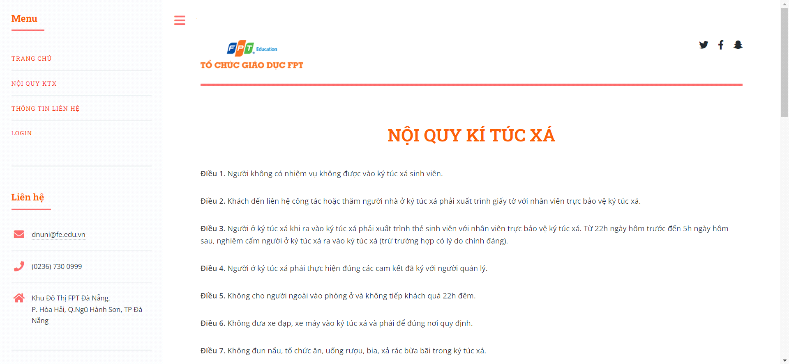

|  |  |  |  |  |
| --- | --- | --- | --- | --- |
| **Screen** | ***Viewing dormitory's rules*** | | | |
| **Description** | | Viewing the dormitory's rules | | |
| **Screen Access** | | Guest clicks **“Nội quy KTX”** on the left banner | | |
| **Screen Content** | | | | |
| **Item** | | **Type** | **Data** | **Description** |
| Nội quy Ký túc xá | | Label – String (1000) |  | Rules of the dormitory |

* ***Viewing contact information***

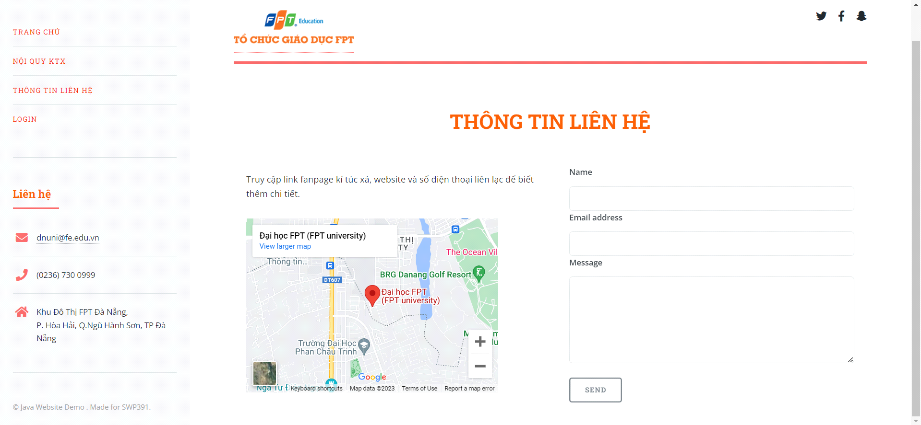

|  |  |  |  |  |
| --- | --- | --- | --- | --- |
| **Screen** | ***Viewing contact information*** | | | |
| **Description** | | Viewing the current contact information of dormitory's office. | | |
| **Screen Access** | | Guest click **“Thông tin liên hệ”** on the left banner | | |
| **Screen Content** | | | | |
| **Item** | | **Type** | **Data** | **Description** |
| Name | | Label – String (1000) |  | All the current services of the dormitory |

* ***Account register***

|  |  |
| --- | --- |
| Use Case Name | ***Account register*** |
| Use Case ID | UC02 |
| High Level Requirement Ref | High |
| Actor | Guest |
| Description | Allow Guests to register their new accounts. |
| Trigger | N/A |
| Pre-condition | User click **“Đăng nhập”** on the left banner => Choose **“Tạo tài khoản”** |
| Post-processing |  |

* ***Account register***

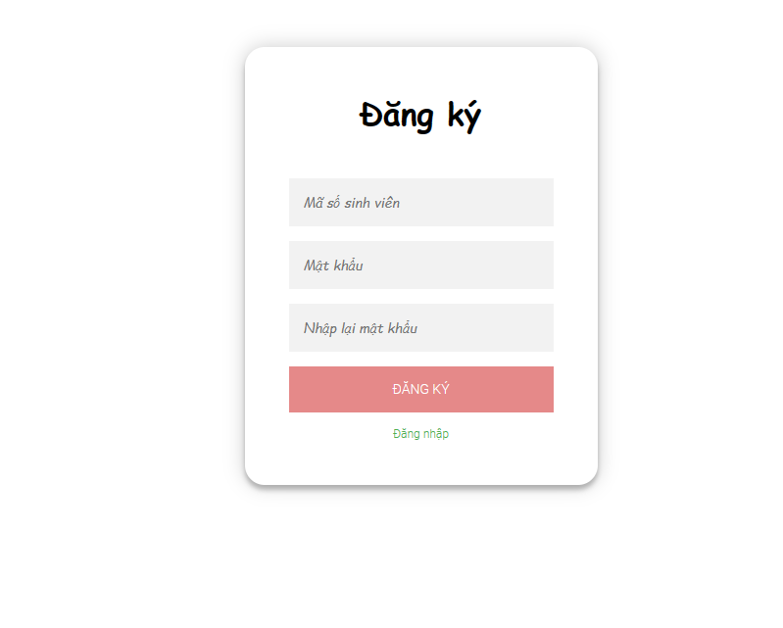

|  |  |  |  |  |  |
| --- | --- | --- | --- | --- | --- |
| **Screen** | Account register | | | | |
| **Description** | Allow Guest to register their own accounts | | | | |
| **Screen Access** | Guest clicks**“Login”**on the left banner => choose **“Tạo tài khoản”** | | | | |
| **Screen Content** | | | | | |
| **Item** | **Type** | **Data** | | **Description** | |
| Tài khoản (Student's ID) | Label - String (8) |  | | Student ID input box of the account. | |
| Mật khẩu | Password - String (100) |  | | Password input box of the account. | |
| Nhập lại mật khẩu | Password - String (100) |  | | Password verify input box of the account. | |
| Đăng ký | Button |  | | Register new account and save it to the database. | |
| Đăng nhập | Link |  | | Get back to Login screen. | |
| **Screen Actions** | | | | | |
| **Action Name** | **Description** | | **Success** | | **Failure** |
| Quay về trang chủ | When Guest clicks on the **Trang chủ** link, the Guest will be redirected to the homepage. | | Return to homepage screen | |  |
| Đăng ký | When Guest clicks the **Đăng ký** button, the system will check the student ID on the dormitory database and FU university database, then check the password. | | Display the message “Đăng ký thành công” and returns to Login screen. | | When the student ID has an account => Display the message “Tài khoản đã tồn tại!”  The screen still shows the current page.  When the student ID does not exist on the FU university database => Display the message “Mã số sinh viên không tồn tại!”  The screen still shows the current page.  When the password and password confirmation do not match => Display the message “Mật khẩu xác nhận không chính xác”.  The screen still shows the current page.  When the value of a cell exceeds the maximum input limit => Display the message “Vượt giới hạn ký tự tối đa!”.  The screen still shows the current page.  When there is a database connection error => Display the message “Lỗi kết nối với cơ sở dữ liệu”.  The screen still shows the current page. |

* ***User***
* ***Managning account***

|  |  |
| --- | --- |
| Use Case Name | ***Managing account*** |
| Use Case ID | UC03 |
| High Level Requirement Ref | High |
| Actor | User |
| Description | Allows User to manage their account such as login, edit personal information, change password. All students' personal information is taken from the database and displayed on the screen. Students can change their personal information and change their password |
| Trigger | N/A |
| Pre-condition | User click **“Đăng nhập”** on the left banner |
| Post-processing |  |

* ***Login***

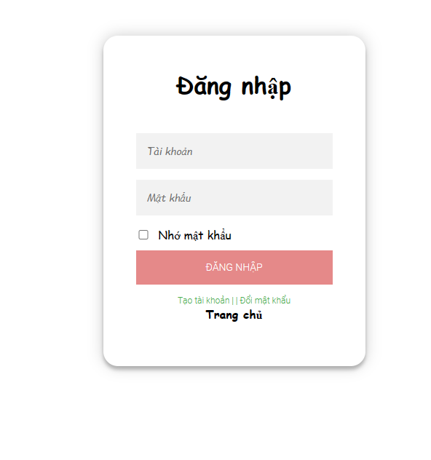

|  |  |  |  |  |
| --- | --- | --- | --- | --- |
| **Screen** | Login | | | |
| **Description** | | Allow users to login into the system | | |
| **Screen Access** | | User click **“Login”** on the left banner | | |
| **Screen Content** | | | | |
| **Item** | | **Type** | **Data** | **Description** |
| Tài khoản | | Textbox – String (100) |  | User name input box for users (Student ID/Manager ID).. |
| Mật khẩu | | Password – String (50) |  | Password input box for users. |
| Nhớ mật khẩu | | Checkbox |  | Save password for logining next time. |
| Đăng nhập | | Button |  | Login to the system. |
| Trang chủ | | Link |  | Cancel login and return to homepage. |
| Tạo tài khoản | | Link |  | Create new account (for guests). |
| Đổi mật khẩu | | Link |  | Navigate user to changing password screen. |
| **Screen Actions** | | | | |
| **Action Name** | | **Description** | **Success** | **Failure** |
| Đăng nhập | | When the User clicks the **Đăng nhập** button, the system will check the validity of the data. | User logged into the system and return to homepage. | When the account does not exist on the system => Show message: “Tài khoản không hợp lệ”  The screen still shows the current page.  When the entered password does not match the information on the database => Display the message: “Mật khẩu không đúng”  The screen still shows the current page.  When the Account or Password box is blank => Show the message “Vui lòng nhập tài khoản và mật khẩu”  The screen still shows the current page.  When the value of a cell exceeds the maximum input limit => Display the message “Vượt giới hạn ký tự tối đa!”.  The screen still shows the current page.  When there is a database connection error => Display the message “Lỗi kết nối với cơ sở dữ liệu”.  The screen still shows the current page. |
| Trang chủ | | Exit the login screen and return to homepage | Return to homepage. |  |
| Tạo tài khoản | | Exit the login screen and navigate to account registering screen | Navigate user to account registering screen |  |
| Đổi mật khẩu | | Exit the login screen and navigate user to the changing password screen. | Navigate user to the changing password screen. |  |

* ***Managing profile***

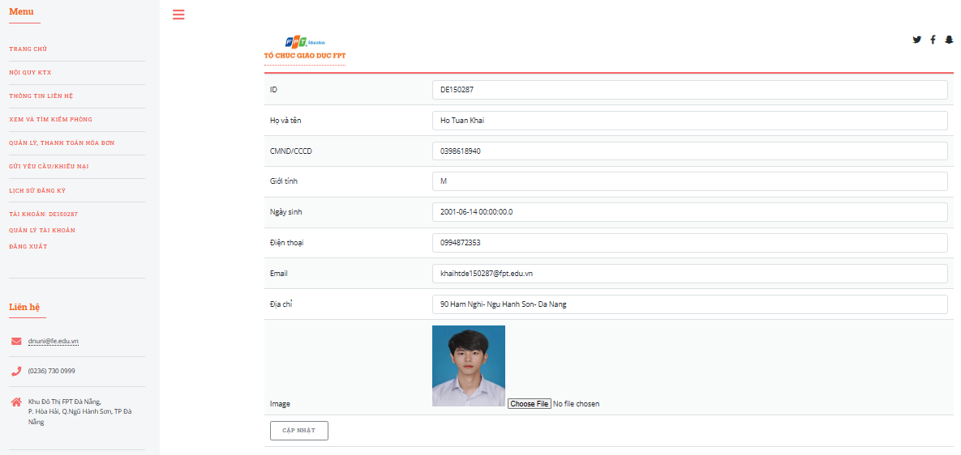

|  |  |  |  |  |  |  |
| --- | --- | --- | --- | --- | --- | --- |
| **Screen** | Managing profile | | | | | |
| **Description** | Allows User to edit all their information such as: Full name, ID/CCCD, Gender, Date of birth, Phone number, Email, Address, Image (except ID - Student ID and Room ID ) | | | | | |
| **Screen Access** | User click **“Quản lý tài khoản”** on the left banner | | | | | |
| **Screen Content** | | | | | | |
| **Item** | **Type** | | **Data** | | **Description** | |
| ID | Label - String (8) | |  | | View the student ID | |
| Họ và tên | Text field – String (50) | |  | | Input box views student 's name | |
| CMND/ CCCD | Text field – String (50) | |  | | Input box views the personal ID of the student | |
| Giới tính | Combobox– String (5) | |  | | Option box views gender of student. | |
| Ngày sinh | Text field – Date | |  | | Input box views date of birth of student. | |
| Điện thoại | Text field – String (11) | |  | | Input box views phone number of student | |
| Email | Text field -String (50) | |  | | Input box views Email of student | |
| Địa chỉ | Text field -String (100) | |  | | Input box views current address of student | |
| Image | File | |  | | View profile picture of student | |
| Choose File | Button - File | |  | | Students have to upload picture from their computer | |
| Cập nhật | Button | |  | | The system saves student information to the database and returns to the Account Management page | |
| **Screen Actions** | | | | | | |
| **Action Name** | | **Description** | | **Success** | | **Failure** | |
| Choose File | | When the User clicks the **Choose File** button, the **Browse** screen appears to upload an avatar file from the computer. | | Exit the Browse screen and the uploaded image is displayed on the profile managing page. | | When the selected file is not in the image format that is allowed to be uploaded such as .jpg, .png, … => Display the message “Tệp ảnh được chọn không hợp lệ. Vui lòng chọn tệp khác”.  When there is a database connection error => Display the message “Lỗi kết nối với cơ sở dữ liệu”.  The screen still shows the current page. | |
| Cập nhật | | User clicks the **Cập nhật** button, the system will check the information before saving the edited personal information to the database. | | The display returns to the profile managing page and the message “Thay đổi thông tin cá nhân thành công” | | When the User leaves the box Full name blank => Display the message “Vui lòng nhập họ và tên”.  When the User leaves the box CMND/CCCD blank => Display the message “Vui lòng nhập CMND/CCCD”.  When the User leaves the Gender box blank => Display the message "Vui lòng nhập giới tính”.  When the User leaves the Date of Birth box blank => Display the message “Vui lòng nhập ngày tháng năm sinh”.  When the User leaves the Phone box blank => Display the message "Vui lòng nhập số điện thoại liên lạc”.  When the User leaves the Email box blank => Display the message “Vui lòng nhập email”.  When the User leaves the Address box blank => Display the message “Vui lòng nhập địa chỉ thường trú”.  When entering the wrong phone number in the Phone box => Display the message “Vui lòng nhập số điện thoại đúng định dạng”.  When entering the Email box in the wrong format of an email => Display the message “Vui lòng nhập email đúng định dạng”.  When entering the Date of Birth box in the wrong date format dd/MM/YYYY => Display the message “Vui lòng nhập ngày sinh đúng định dạng dd/MM/YYYY”.  When the value of a cell exceeds the maximum input limit => Display the message "Vượt giới hạn ký tự tối đa!”.  The screen still shows the current page.  When there is a database connection error => Display the message "Lỗi kết nối cơ sở dữ liệu”.  Màn hình vẫn hiển thị trang hiện tại. | |

* ***Changing password***

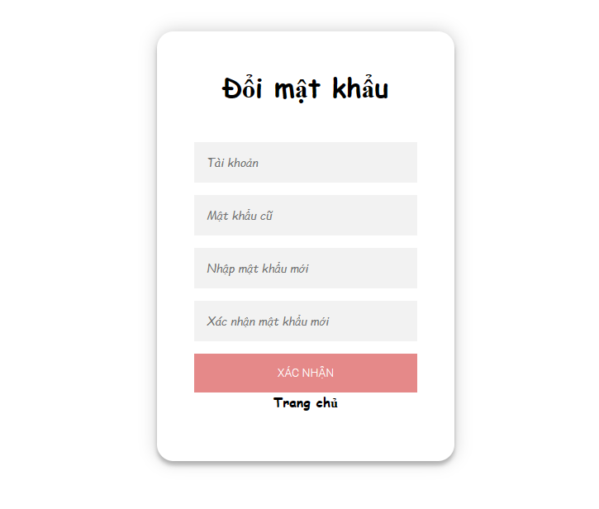

|  |  |  |  |  |  |
| --- | --- | --- | --- | --- | --- |
| **Screen** | Changing password | | | | |
| **Description** | Allow User to change password to log in to the system | | | | |
| **Screen Access** | User may click**“Đổi mật khẩu”** at the login page. | | | | |
| **Screen Content** | | | | | |
| **Item** | **Type** | **Data** | | **Description** | |
| Tài khoản | Textbox – String (100) |  | | Input box of username. | |
| Mật khẩu cũ | Password - String (100) |  | | Input box of current password. | |
| Nhập mật khẩu mới | Password - String (100) |  | | Input box of new password. | |
| Xác nhận mật khẩu mới | Password - String (100) |  | | Input box of veriying new password. | |
| Trang chủ | Link |  | | Cancel changing password and return to homepage. | |
| Xác nhận | Button |  | | Change password and save new password of the user to database. | |
| **Screen Actions** | | | | | |
| **Action Name** | **Description** | | **Success** | | **Failure** |
| Xác nhận | When the User clicks the **Change Password** button, the system will compare the previous old password with the new password before performing the update. | | Display the message “Đổi mật khẩu thành công” and the display returns to the Home page. Update User's password on database. | | The old password and the new password are the same => Display the message “Mật khẩu mới trừng với mật khẩu cũ”.  The screen still shows the current page.  When the new password and confirm the new password do not match => Display the message "Mật khẩu xác nhận không chính xác".  The screen still shows the current page.  When the value of a cell exceeds the maximum input limit => Display the message "Vượt giới hạn ký tự tối đa!".  The screen still shows the current page.  When there is a database connection error => Display the message "“Lỗi kết nối với cơ sở dữ liệu”.  The screen still shows the current page. |

* ***View and search room***

|  |  |
| --- | --- |
| Use Case Name | View and search all current rooms in the dormitory |
| Use Case ID | UC04 |
| High Level Requirement Ref | High |
| Actor | User |
| Description | Allows User to view rooms, search for rooms and detailed information of each room (room type, number of people/room, available common facilities, prices, ...) of the dormitory. |
| Trigger | N/A |
| Pre-condition | User click**“Xem và tìm kiếm phòng”** on the left banner. |

* ***View and search room***

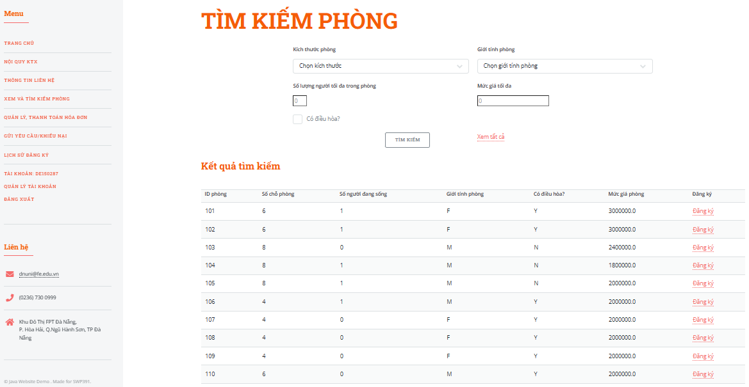

|  |  |  |  |
| --- | --- | --- | --- |
| **Screen** | View and search room | | |
| **Description** | Display list of rooms and search for rooms | | |
| **Screen Access** | Student click “**Xem và tìm kiếm phòng"** on the left banner. | | |
| **Screen Content** | | | |
| **Item** | **Type** | **Data** | **Description** |
| Kích thước phòng | Combobox |  | Choose the number of people living in the room. |
| Giới tính phòng | Combobox |  | Choose gender of people living in the room. |
| Số lượng người tối đa trong phòng | Number |  | View the maximum number of people living in the room. |
| Mức giá tối đa | Text field – Integer |  | Input box of maximum price of the room |
| Có điều hòa? | Checkbox |  | Choose if the room will have air-conditioner or not. |
| Giới tính phòng | Label – String (1) |  | View gender of people living in the room |
| Có điều hòa? | Label – String (1) |  | View if the room has air-conditioner or not. |
| Tìm kiếm | Button |  | Displays a list of all matching rooms that match the selected requirements (exclude those that are full) |
| Xem tất cả | Link |  | Show a list of all the rooms in the dormitory (exclude those that are full) |
| ID phòng | Label - Integer |  | View ID of the room. |
| Số chỗ phòng | Label – Integer |  | View capacity of the room. |
| Số người đang sống | Label – Integer |  | View the number of people living in the room. |
| Giới tính phòng | Label – String (10) |  | View gender of people living in the room. |
| Có điều hòa? | Label – String (1) |  | View if the room has air-conditioner or not. |
| Mức giá phòng | Label – Number |  | View the cost of the room |
| Đăng ký | Link |  | Navigate user to the register room screen. |
| Paging | Link |  | Allow paging if the page has giant database. |
| **Screen Actions** | | | |
| **Action Name** | **Description** | **Success** | **Failure** |
| Tìm kiếm | When the user clicks on **Tìm Kiếm,** the system will perform a query to retrieve the list of rooms that match the user's selected requirements and display it on the screen of that page. | If the user does not enter anything in the search boxes, the system will display all rooms in the room list table.  In contrast, the screen displays a list of rooms that match the user's selected requirements. | When no room is found that matches the request, the user selects the screen to display the message “Không tìm thấy phòng phụ hợp”  When the value of a cell exceeds the maximum input limit => Display the message “Vượt giới hạn ký tự tối đa!”.  The screen still shows the current page.  When there is a database connection error => Display the message "Lỗi kết nối cơ sở dữ liệu”. |
| Xem tất cả | When the user clicks on **Xem tất cả**,the system now queries the database to get a list of all the rooms in the system except those rooms that are full. | The screen shows a list of all rooms available in the system. | The screen shows a list of all available rooms in the whole room system.  When there is a database connection error => Display the message "Lỗi kết nối cơ sở dữ liệu”. |
| Paging | When there are less than or equal to 10 fields, there is no paging.  When there are more than 10 data fields, paging will be used.  Clicking on Prev/Next will go to the next/next page from the current page if there is still a previous/next page. Click the <</>> button to go to the first/last page. | Navigate to the required page. | When there is a database connection error => Display the message "Lỗi kết nối cơ sở dữ liệu”. |
| Đăng ký | When the user click "**Đăng ký**", website will take user to the room registering screen. | Navigate to the room registering screen. |  |

* ***Register room and Registration history***

|  |  |
| --- | --- |
| Use Case Name | Register room and Room registering history |
| Use Case ID | UC05 |
| High Level Requirement Ref | High |
| Actor | User |
| Description | Allows User to register for a room that he wants to rent in the dormitory for a semester (four months) and review the history of previous bookings |
| Trigger | N/A |
| Pre-condition | User in the View rooms page select "**Đăng ký**" to register room. To view room registering history, click "**Lịch sử đăng ký**" on the left banner. |
| Post-processing |  |

* ***Register room***

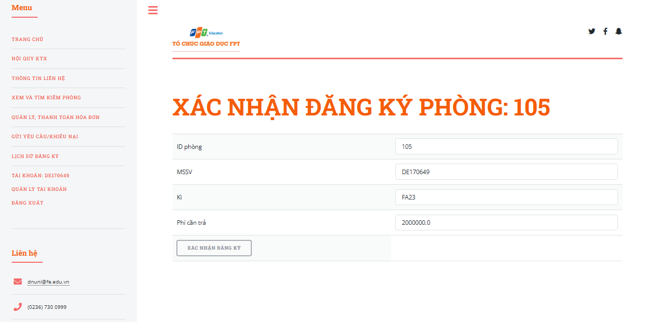

|  |  |  |  |
| --- | --- | --- | --- |
| **Screen** | Register room | | |
| **Description** | Allow students register their room in the dormitory. | | |
| **Screen Access** | User click “**Đăng ký**” nearby the specific room on the “**Xem và Tìm kiếm phòng**” page | | |
| **Screen Content** | | | |
| **Item** | **Type** | **Data** | **Description** |
| ID Phòng | Label – String |  | View Room ID. |
| MSSV | Label – String |  | View Student ID who register the room. |
| Kì | Label – String |  | View semester to register. |
| Phí cần trả | Label - Integer |  | Total cost to pay for registering. |
| Đăng ký | Button |  | Create a register room request and save it to database. |
| **Screen Actions** | | | |
| **Action Name** | **Description** | **Success** | **Failure** |
| Đăng ký | When the user clicks on **Đăng ký**, the system will create a room booking request to the manager and save the booking history for students at Room registering history. | Display the message “Đăng ký thành công” and return to the Home screen. | When there is a database connection error => Display the message "Lỗi kết nối cơ sở dữ liệu”. |

* ***Registration history***

|  |  |  |  |
| --- | --- | --- | --- |
| **Screen** | Registration history | | |
| **Description** | Allows students to view a history of room booking requests they have made in the past. | | |
| **Screen Access** | User click “**Lịch sử đăng ký**” on the left banner. | | |
| **Screen Content** | | | |
| **Item** | **Type** | **Data** | **Description** |
| ID Phòng | Label – Integer |  | View ID of registerd rooms. |
| Đăng ký cho kì | Label – String (50) |  | View the semester of registration. |
| Trạng thái đăng ký | Label – String (10) |  | View the registration’s status. |
| Thời gian đăng kí | Label – Date |  | View time of registration. |
| Hủy | Button |  | Cancel registration. |
| Paging | Link |  | Allow paging when website has giant database. |
| Trở về trang chủ | Link |  | Cancel viewing and return to homepage. |
| **Screen Actions** | | | |
| **Action Name** | **Description** | **Success** | **Failure** |
| Phân trang | When there are less than or equal to 10 fields, there is no paging  When there are more than 10 data fields, paging will be used.  Clicking on Prev/Next will go to the next/next page from the current page if there is still a previous/next page. Click the <</>> button to go to the first/last page. | Navigate to requested page. | When there is a database connection error => Display the message "Lỗi kết nối cơ sở dữ liệu”. |
| Hủy | When the user click “**Hủy**”, system will delete the room booking request from database. | Registration will be remove from database. | When there is a database connection error => Display the message "Lỗi kết nối cơ sở dữ liệu”. |

* ***View payment and bills***

|  |  |
| --- | --- |
| Use Case Name | View payment and bills |
| Use Case ID | UC06 |
| High Level Requirement Ref | Allow students to view their bills and pay for them. |
| Actor | User |
| Description | Allows students to view bill information, pay for rooms before each semester, view electricity, water, bills and pay electricity and water bills. |
| Trigger | N/A |
| Pre-condition | User click **“Quản lý, thanh toán hóa đơn phòng”** on the left banner to view bills for their room, click “**Quản lý, thanh toán hóa đơn điện nước”** to view their bills for electricity and water. |
| Post-processing |  |

* ***View bills and payment for room renting***

|  |  |  |  |
| --- | --- | --- | --- |
| **Screen** | View bills and payment for room renting. | | |
| **Description** | Students view all the bills of room renting and pay for them. | | |
| **Screen Access** | User chọn **“Quản lý, thanh toán hóa đơn phòng”** on the left banner. | | |
| **Screen Content** | | | |
| **Item** | **Type** | **Data** | **Description** |
| ID | Label – Integer |  |  |
| MSSV |  |  |  |
| ID Phòng | Label – Integer |  | View ID of registerd rooms. |
| Đăng ký cho kì | Label – String (50) |  | View the semester of registration. |
| Trạng thái đăng ký | Label – String (10) |  | View the registration’s status. |
| Thời gian đăng kí | Label – Date |  | View time of registration. |
| Thanh toán | Link |  | Navigate user to payment method page. |
| Mức giá phòng | Label – Float |  | Hiển thị mức giá phòng |
| **Screen Actions** | | | |
| **Action Name** | **Description** | **Success** | **Failure** |
| Thanh toán | When user click”**Thanh toán**”, system will take user to payment method page to finish their payment. | Navigate user to payment method page to complete their payment. | When there is a database connection error => Display the message "Lỗi kết nối cơ sở dữ liệu”. |

* ***View and payment for electricity, water***

|  |  |  |  |  |  |  |
| --- | --- | --- | --- | --- | --- | --- |
| **Screen** | | View and payment for electricity, water. | | | | |
| **Description** | | Help students view their electricity and water bills and pay for them. | | | | |
| **Screen Access** | | User click **“Quản lý, thanh toán hóa đơn điện nước”** | | | | |
| **Screen Content** | | | | | | |
| **Item** | | **Type** | | **Data** | | **Description** |
| Kỳ | | Label – String(50) | |  | | View semester of the bill |
| Số điện cũ | | Label – Integer | |  | | View old electricity usage. |
| Số điện đã dùng | | Label – Integer | |  | | View new electricity uage. |
| Số nước cũ | | Label – Integer | |  | | View old water usage. |
| Số nước đã dùng | | Label – Integer | |  | | View new water usage. |
| Trạng thái | | Label – String(10) | |  | | View status of payment for the bills. |
| Tổng tiền | | Label – Float | |  | | View cost of the bill. |
| Thanh toán | | Link | |  | | Navigate user to payment method screen. |
| **Screen Actions** | | | | | | |
| **Action Name** | | **Description** | | **Success** | | **Failure** |
| Thanh toán | When user click”**Thanh toán**”, system will take user to payment method page to finish their payment. | | Navigate user to payment method page to complete their payment. | | When there is a database connection error => Display the message "Lỗi kết nối cơ sở dữ liệu”. | |

* ***Send changing room request and complaints***

|  |  |
| --- | --- |
| Use Case Name | Send changing room request and complaints |
| Use Case ID | UC07 |
| High Level Requirement Ref | Allow user to send changing room request and complaints to managers. |
| Actor | User |
| Description | All request and complaints of user will be inserted to database. |
| Trigger | N/A |
| Pre-condition | User click “**Gửi yêu cầu/khiếu nại”** on the left banner. |
| Post-processing |  |

* ***Send changing room request and complaints***

|  |  |  |  |
| --- | --- | --- | --- |
| **Screen** | Send changing room request and complaints | | |
| **Description** | Choose to send changing room request or to send complaints | | |
| **Screen Access** | User click “**Gửi yêu cầu/khiếu nại”** | | |
| **Screen Content** | | | |
| **Item** | **Type** | **Data** | **Description** |
| Chọn loại yêu cầu | Combobox |  | Option box to choose what user want to do. |
| Chọn loại yêu cầu | Label– String |  | View option box. |
| Bấm để xác nhận | Label– String |  | View confirm button. |
| Chọn | Link |  | Navigate user to the changing room request or sending complaints page. |
| **Screen Actions** | | | |
| **Action Name** | **Description** | **Success** | **Failure** |
| Chọn | When users click “Chọn”, system will take user to the page they want. | Navigate to chosen page. | When there is a database connection error => Display the message "Lỗi kết nối cơ sở dữ liệu”. |

* ***Send complaint and maintenance request***

|  |  |  |  |
| --- | --- | --- | --- |
| **Screen** | Gửi yêu cầu bảo trì thiết bị và khiếu nại | | |
| **Description** | Gửi yêu cầu bảo trì thiết bị và khiếu nại user đang gặp phải | | |
| **Screen Access** | User rê chuột qua “**Gửi yêu cầu/khiếu nại”** => Chọn **“Yêu cầu bảo trì thiết bị/Khiếu nại”** | | |
| **Screen Content** | | | |
| **Item** | **Type** | **Data** | **Description** |
| Chọn loại yêu cầu | Combobox |  | Option box to choose what user want to do. |
| Chọn loại yêu cầu | Label– String |  | View option box. |
| Bấm để xác nhận | Label– String |  | View confirm button. |
| Chọn | Link |  | Navigate user to the changing room request or sending complaints page. |
| Gửi | Button |  | Send complaints to manager and save it to database. |
| Tiêu đề | Combobox |  | Option box to choose type of complaint. |
| Tiêu đề | Label– String |  | View type of complaint. |
| Nội dung khiếu nại | Text field – String (1000) |  | Input box for content of complaint. |
| **Screen Actions** | | | |
| **Action Name** | **Description** | **Success** | **Failure** |
| Gửi | When the user clicks ” **Gửi”**  The system will enter the information of the request and complaint form into the database and wait for the management response. | Return to the main screen and display the message “Gửi yêu cầu, khiếu nại thành công” | When there is a database connection error => Display the message "Lỗi kết nối cơ sở dữ liệu”.  When the value of a cell exceeds the maximum input limit => Display the message “Vượt giới hạn ký tự tối đa!”.  When the title has not been entered => Display the message “Bạn chưa nhập tiêu đề!”  When you have not entered the content => Display the message “Bạn chưa nhập nội dung yêu cầu/khiếu nại!”. |
| Chọn | When users click “Chọn”, system will take user to the page they want. | Navigate to chosen page. | When there is a database connection error => Display the message "Lỗi kết nối cơ sở dữ liệu”. |

* ***Manager***
* ***Managing account***

|  |  |
| --- | --- |
| Use Case Name | Quản lý tài khoản |
| Use Case ID | UC10 |
| High Level Requirement Ref | High |
| Actor | Manager |
| Description | Allow Manager to manage his account such as login, edit personal information, change password. All personal information of the Manager is taken from the database and displayed on the screen. Manager can change his personal information, change his password |
| Trigger | N/A |
| Pre-condition | Manager click **“Login”** on the left banner. |
| Post-processing |  |

* ***Login***



|  |  |  |  |  |
| --- | --- | --- | --- | --- |
| **Screen** | Login | | | |
| **Description** | | Allow users to login into the system | | |
| **Screen Access** | | User click **“Login”** on the left banner | | |
| **Screen Content** | | | | |
| **Item** | | **Type** | **Data** | **Description** |
| Tài khoản | | Textbox – String (100) |  | User name input box for users (Student ID/Manager ID).. |
| Mật khẩu | | Password – String (50) |  | Password input box for managers. |
| Nhớ mật khẩu | | Checkbox |  | Save password for logining next time. |
| Đăng nhập | | Button |  | Login to the system. |
| Trang chủ | | Link |  | Cancel login and return to homepage. |
| Tạo tài khoản | | Link |  | Create new account (for guests). |
| Đổi mật khẩu | | Link |  | Navigate user to changing password screen. |
| **Screen Actions** | | | | |
| **Action Name** | | **Description** | **Success** | **Failure** |
| Đăng nhập | | When the User clicks the **Đăng nhập** button, the system will check the validity of the data. | User logged into the system and return to homepage. | When the account does not exist on the system => Show message: “Tài khoản không hợp lệ”  The screen still shows the current page.  When the entered password does not match the information on the database => Display the message: “Mật khẩu không đúng”  The screen still shows the current page.  When the Account or Password box is blank => Show the message “Vui lòng nhập tài khoản và mật khẩu”  The screen still shows the current page.  When the value of a cell exceeds the maximum input limit => Display the message “Vượt giới hạn ký tự tối đa!”.  The screen still shows the current page.  When there is a database connection error => Display the message “Lỗi kết nối với cơ sở dữ liệu”.  The screen still shows the current page. |
| Trang chủ | | Exit the login screen and return to homepage | Return to homepage. |  |
| Tạo tài khoản | | Exit the login screen and navigate to account registering screen | Navigate user to account registering screen |  |
| Đổi mật khẩu | | Exit the login screen and navigate user to the changing password screen. | Navigate user to the changing password screen. |  |

* ***Managing profile***

|  |  |  |  |  |  |  |
| --- | --- | --- | --- | --- | --- | --- |
| **Screen** | Managing profile | | | | | |
| **Description** | Allows User to edit all their information such as: Full name, ID/CCCD, Gender, Date of birth, Phone number, Email, Address, Image (except ID - Manager ID) | | | | | |
| **Screen Access** | User click **“Quản lý tài khoản”** on the left banner | | | | | |
| **Screen Content** | | | | | | |
| **Item** | **Type** | | **Data** | | **Description** | |
| ID | Label - String (8) | |  | | View the manager ID | |
| Họ và tên | Text field – String (50) | |  | | Input box views manager 's name | |
| CMND/ CCCD | Text field – String (50) | |  | | Input box views the personal ID of the manager | |
| Giới tính | Combobox– String (5) | |  | | Option box views gender of manager. | |
| Ngày sinh | Text field – Date | |  | | Input box views date of birth of manager. | |
| Điện thoại | Text field – String (11) | |  | | Input box views phone number of manager. | |
| Email | Text field -String (50) | |  | | Input box views Email of manager. | |
| Địa chỉ | Text field -String (100) | |  | | Input box views current address of manager. | |
| Image | File | |  | | View profile picture of manager. | |
| Choose File | Button - File | |  | | Students have to upload picture from their computer | |
| Cập nhật | Button | |  | | The system saves manager information to the database and returns to the Account Management page | |
| **Screen Actions** | | | | | | |
| **Action Name** | | **Description** | | **Success** | | **Failure** | |
| Choose File | | When the User clicks the **Choose File** button, the **Browse** screen appears to upload an avatar file from the computer. | | Exit the Browse screen and the uploaded image is displayed on the profile managing page. | | When the selected file is not in the image format that is allowed to be uploaded such as .jpg, .png, … => Display the message “Tệp ảnh được chọn không hợp lệ. Vui lòng chọn tệp khác”.  When there is a database connection error => Display the message “Lỗi kết nối với cơ sở dữ liệu”.  The screen still shows the current page. | |
| Cập nhật | | User clicks the **Cập nhật** button, the system will check the information before saving the edited personal information to the database. | | The display returns to the profile managing page and the message “Thay đổi thông tin cá nhân thành công” | | When the User leaves the box Full name blank => Display the message “Vui lòng nhập họ và tên”.  When the User leaves the box CMND/CCCD blank => Display the message “Vui lòng nhập CMND/CCCD”.  When the User leaves the Gender box blank => Display the message "Vui lòng nhập giới tính”.  When the User leaves the Date of Birth box blank => Display the message “Vui lòng nhập ngày tháng năm sinh”.  When the User leaves the Phone box blank => Display the message "Vui lòng nhập số điện thoại liên lạc”.  When the User leaves the Email box blank => Display the message “Vui lòng nhập email”.  When the User leaves the Address box blank => Display the message “Vui lòng nhập địa chỉ thường trú”.  When entering the wrong phone number in the Phone box => Display the message “Vui lòng nhập số điện thoại đúng định dạng”.  When entering the Email box in the wrong format of an email => Display the message “Vui lòng nhập email đúng định dạng”.  When entering the Date of Birth box in the wrong date format dd/MM/YYYY => Display the message “Vui lòng nhập ngày sinh đúng định dạng dd/MM/YYYY”.  When the value of a cell exceeds the maximum input limit => Display the message "Vượt giới hạn ký tự tối đa!”.  The screen still shows the current page.  When there is a database connection error => Display the message "Lỗi kết nối cơ sở dữ liệu”.  Màn hình vẫn hiển thị trang hiện tại. | |

* ***Changing password***



|  |  |  |  |  |  |
| --- | --- | --- | --- | --- | --- |
| **Screen** | Changing password | | | | |
| **Description** | Allow User to change password to log in to the system | | | | |
| **Screen Access** | User may click**“Đổi mật khẩu”** at the login page. | | | | |
| **Screen Content** | | | | | |
| **Item** | **Type** | **Data** | | **Description** | |
| Tài khoản | Textbox – String (100) |  | | Input box of username. | |
| Mật khẩu cũ | Password - String (100) |  | | Input box of current password. | |
| Nhập mật khẩu mới | Password - String (100) |  | | Input box of new password. | |
| Xác nhận mật khẩu mới | Password - String (100) |  | | Input box of veriying new password. | |
| Trang chủ | Link |  | | Cancel changing password and return to homepage. | |
| Xác nhận | Button |  | | Change password and save new password of the user to database. | |
| **Screen Actions** | | | | | |
| **Action Name** | **Description** | | **Success** | | **Failure** |
| Xác nhận | When the User clicks the **Change Password** button, the system will compare the previous old password with the new password before performing the update. | | Display the message “Đổi mật khẩu thành công” and the display returns to the Home page. Update User's password on database. | | The old password and the new password are the same => Display the message “Mật khẩu mới trừng với mật khẩu cũ”.  The screen still shows the current page.  When the new password and confirm the new password do not match => Display the message "Mật khẩu xác nhận không chính xác".  The screen still shows the current page.  When the value of a cell exceeds the maximum input limit => Display the message "Vượt giới hạn ký tự tối đa!".  The screen still shows the current page.  When there is a database connection error => Display the message "“Lỗi kết nối với cơ sở dữ liệu”.  The screen still shows the current page. |

* ***Notifications mangement***

|  |  |
| --- | --- |
| Use Case Name | Notifications management |
| Use Case ID | UC11 |
| High Level Requirement Ref | Allow manager to manage all the notifications of dormitory. |
| Actor | Manager |
| Description | All notifications are taken from database. Managers can add, edit and delete them. |
| Trigger | N/A |
| Pre-condition | Manager sau khi đăng nhập kích vào **“Quản lý thông báo”** ở thanh điều hướng bên trái |
| Post-processing |  |

* ***View posted notifications***

|  |  |  |  |  |  |
| --- | --- | --- | --- | --- | --- |
| **Screen** | View posted notifications | | | | |
| **Description** | View list of all notifications posted by managers. | | | | |
| **Screen Access** | Manager click **“Quản lý thông báo”** on the left banner. | | | | |
| **Screen Content** | | | | | |
| **Item** | **Type** | | **Data** | **Description** | |
| Thêm thông báo | Button | |  | Manager click to add new notifications. | |
| ID | Label – String (20) | |  | View notifications ID | |
| Tiêu đề | Label – String (200) | |  | View subject of notifications. | |
| Người chỉnh sửa | Label – String (50) | |  | View author of notifications. | |
| Chỉnh sửa lần cuối | Label – Date | |  | View date of creating notification. | |
| Chức năng | Label – String (20) | |  | View functions to do with notifications. | |
| Sửa | Link | |  | When the user clicks on **Sửa** in any line, the user will be taken to edit screen. | |
| Xóa | Link | |  | When the user clicks on **Xóa** in a row, it will delete the notification in that line from the database. | |
| Paging | Link | |  | Paging if website has giant database. | |
| **Screen Actions** | | | | | |
| **Action Name** | **Description** | **Success** | | | **Failure** |
| Thêm thông báo | When the user clicks on **Thêm thông báo**, the system switches to the Create new message page. | Navigate to add new notification page. | | | When there is a database connection error => Display the message "Lỗi kết nối cơ sở dữ liệu”.  Màn hình vẫn hiển thị trang hiện tại. |
| Sửa | When the user clicks on **Sửa** in any line, the system will perform a query to get the corresponding message in that line. The system will then move to the Edit message content screen. | Navigate to edit notification page. | | | When there is a database connection error => Display the message "Lỗi kết nối cơ sở dữ liệu”. |
| Xóa | When the user clicks on **Xóa** on any line, the system will perform a query to delete that notification from database. | A popup will appear with message ”Bạn chắc chắn muốn xóa?”. If user click yes, the notification will be deleted from database. If not, it will cancel deleting action. | | | When there is a database connection error => Display the message "Lỗi kết nối cơ sở dữ liệu”. |
| Paging | When there are less than or equal to 10 fields, there is no pagination  When there are more than 10 data fields, show pagination  Clicking on Prev/Next will go to the next/next page from the current page if there is still a previous/next page. Click the <</>> button to go to the first/last page. | Navigate to required page. | | | When there is a database connection error => Display the message "Lỗi kết nối cơ sở dữ liệu”. |

* ***Create new notifications***

|  |  |  |  |  |  |
| --- | --- | --- | --- | --- | --- |
| **Screen** | Create new notifications | | | | |
| **Description** | Allow manager to create new notifications | | | | |
| **Screen Access** | Manager click**“Quản lý thông báo”** => Choose**“Thêm thông báo”** | | | | |
| **Screen Content** | | | | | |
| **Item** | **Type** | **Data** | | | **Description** |
| Tiêu đề | Text field – String (200) |  | | | Input box for subject of the notification. |
| Nội dung | Text Area – String (1000) |  | | | Input box for content of the notification. |
| Ảnh | Label– String |  | | | View picture of the notification. |
| Choose Image | Button - File |  | | | Managers upload image from their computer. |
| Cancel | Button |  | | | Return to previous screen. |
| Tạo | Button |  | | | Confirm creating notifications. |
| **Screen Actions** | | | | | |
| **Action Name** | **Description** | | **Success** | **Failure** | |
| Choose File | When the User clicks the **Choose File** button, the **Browse** screen appears to upload an avatar file from the computer. | | Exit the Browse screen and the uploaded image is displayed on the profile managing page. | When the selected file is not in the image format that is allowed to be uploaded such as .jpg, .png, … => Display the message “Tệp ảnh được chọn không hợp lệ. Vui lòng chọn tệp khác”.  When there is a database connection error => Display the message “Lỗi kết nối với cơ sở dữ liệu”.  The screen still shows the current page. | |
| Cancel | When the user clicks **Cancel**, the system will go to the previous screen | | View | Khi có lỗi kết nối cơ sở dữ liệu => Hiển thị thông báo “Lỗi kết nối cơ sở dữ liệu” | |
| Tạo | When the user clicks on **Tạo**, the system checks the validity of the data. | | Return to the posted notifications screen, save the new notification to the database, and display the message “Tạo thông báo thành công”. | When users leave the **Tiêu đề** box blank => The system will notify "Vui lòng điền tiêu đề".  When you leave the Content box blank => the system will notify " Vui lòng điền nội dung”  When the value of a cell exceeds the maximum input limit => Display the message “Vượt giới hạn ký tự tối đa!”.  When there is a database connection error => Display the message “Lỗi kết nối với cơ sở dữ liệu”. | |

* ***Edit Notifications***

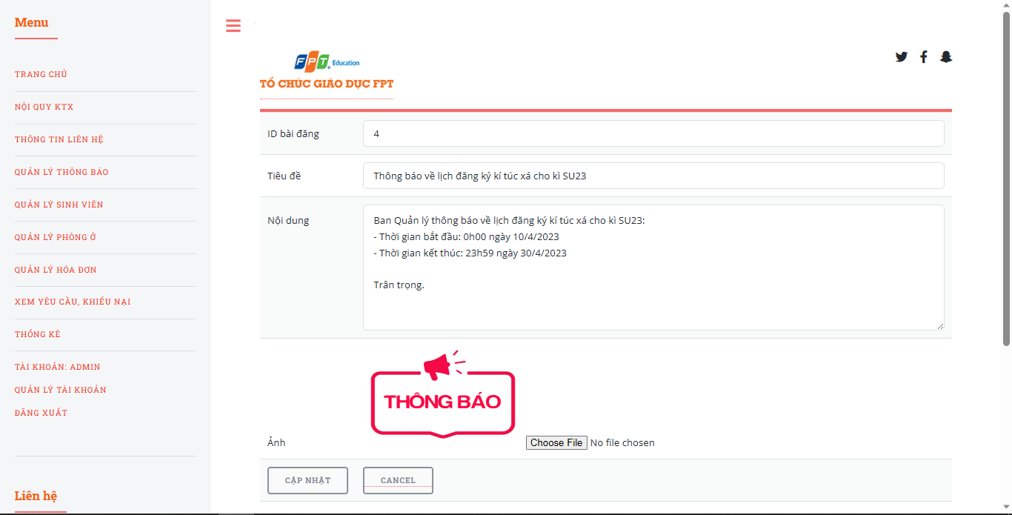

|  |  |  |  |  |  |
| --- | --- | --- | --- | --- | --- |
| **Screen** | Edit Notifications | | | | |
| **Description** | Allow manager to edit posted notifications. | | | | |
| **Screen Access** | Manager click **“Quản lý thông báo” =>** choose **“Sửa”** nearby the needed notifications. | | | | |
| **Screen Content** | | | | | |
| **Item** | **Type** | **Data** | | | **Description** |
| ID Bài đăng | Label – String (20) |  | | | View the ID of notification. |
| Tiêu đề | Text field – String (200) |  | | | Input box of the title of notification. |
| Nội dung | Text Area – String (1000) |  | | | Input box for content of the notification. |
| Ảnh | Label – String |  | | | View picture of the notification. |
| Choose Image | Button - File |  | | | Managers upload image from their computers. |
| Cancel | Button |  | | | Return to previous screen. |
| Cập nhật | Button |  | | | Save all changes to the database and return to the previous screen. |
| **Screen Actions** | | | | | |
| **Action Name** | **Description** | | **Success** | **Failure** | |
| Choose File | When the User clicks the **Choose File** button, the **Browse** screen appears to upload an avatar file from the computer. | | Exit the Browse screen and the uploaded image is displayed on the profile managing page. | When the selected file is not in the image format that is allowed to be uploaded such as .jpg, .png, … => Display the message “Tệp ảnh được chọn không hợp lệ. Vui lòng chọn tệp khác”.  When there is a database connection error => Display the message “Lỗi kết nối với cơ sở dữ liệu”.  The screen still shows the current page. | |
| Cancel | When manager click **Cancel**, the system will navigate to the previous screen and cancel all changes. | | Navigate to previous screen. | When there is a database connection error => Display the message “Lỗi kết nối với cơ sở dữ liệu”. | |
| Cập nhật | When manager click on Cập nhật button, the system will save all changes made to the database and navigate back to the previous screen. | | Navigate back to notifications list. | When users leave the **Tiêu đề** box blank => The system will notify "Vui lòng điền tiêu đề".  When you leave the **Nội dung** box blank => the system will notify " Vui lòng điền nội dung”  When the value of a cell exceeds the maximum input limit => Display the message “Vượt giới hạn ký tự tối đa!”.  When there is a database connection error => Display the message “Lỗi kết nối với cơ sở dữ liệu”. | |

* ***Manage room booking request***

|  |  |
| --- | --- |
| Use Case Name | Manage room renting |
| Use Case ID | UC12 |
| High Level Requirement Ref | Allows manager to adjust and manage room rentals such as viewing payment status, deleting room requests, managing room change requests. |
| Actor | Manager |
| Description | All information about the room rental is taken from the database and displayed on the screen. Management can view, confirm or delete booking requests and respond to room change requests. |
| Trigger | N/A |
| Pre-condition | Manager click “**Quản lý phòng ở”**on the left banner => Choose **“Quản lý đăng kí phòng”** |
| Post-processing |  |

* ***Manage booking request from students***

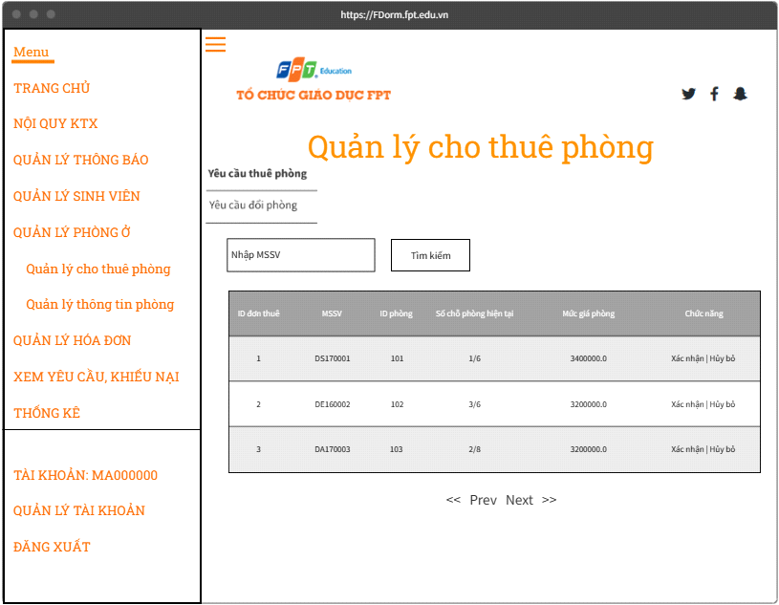

|  |  |  |  |
| --- | --- | --- | --- |
| **Screen** | Manage booking request from students | | |
| **Description** | Manage booking requests from students like approve or cancel them. | | |
| **Screen Access** | Manager rê chuột qua “**Quản lý phòng ở”** => Chọn mục **“Quản lý đăng kí phòng” =>** Chọn tab **“Yêu cầu thuê phòng”** | | |
| **Screen Content** | | | |
| **Item** | **Type** | **Data** | **Description** |
| Nhập MSSV | Search Box |  | Input box for student ID to search matching rooms. |
| Tìm kiếm | Button |  | Button for searching |
| ID đơn thuê | Label – Integer |  | View ID of booking request. |
| MSSV | Label – String (8) |  | View ID of the student who book request. |
| ID phòng | Label - Integer |  | View room ID |
| Số chỗ phòng hiện tại | Label – String (10) |  | View slots available in the room. |
| Mức giá | Label – Float |  | View the cost of the room. |
| Chức năng | Label – String (20) |  | View actions manager can do with the request. |
| Xác nhận | Link |  | When the user clicks on **Xác nhận** in any line, it will confirm the booking of that line. |
| Hủy bỏ | Link |  | When the user clicks **Hủy bỏ** on any line, it will cancel the reservation for that line. |
| Paging | Link |  | Allow paging when website has giant database. |
| **Screen Actions** | | | |
| **Action Name** | **Description** | **Success** | **Failure** |
| Tìm kiếm | When the user clicks on **Tìm kiếm**, the system will perform a room search query according to the data entered by the user in the **MSSV** box. | If the user does not enter anything in the Search box, the system will display the entire rental application.  Otherwise, display the search results on the rental application table. | When the value of a cell exceeds the maximum input limit => Display the message “Vượt giới hạn ký tự tối đa!”.  When there is a database connection error => Display the message “Lỗi kết nối với cơ sở dữ liệu”.  When the system does not find any application, it will display the message “Không tìm thấy”. |
| Xác nhận | When the user clicks on **Xác nhận** in any line, the system will update the rental status. | Mark booking request as “Success” | When there is a database connection error => Display the message "Lỗi kết nối cơ sở dữ liệu”. |
| Hủy bỏ | When the user clicks **Hủy bỏ** on any line, the system will update the rental status. | Mark booking request as“Rejected” | When there is a database connection error => Display the message "Lỗi kết nối cơ sở dữ liệu”. |
| Paging | When there are less than or equal to 10 fields, there is no pagination  When there are more than 10 data fields, show pagination  Clicking on Prev/Next will go to the next/next page from the current page if there is still a previous/next page. Click the <</>> button to go to the first/last page. | Navigate to required page. | When there is a database connection error => Display the message "Lỗi kết nối cơ sở dữ liệu”. |

* ***Manage changing room request***

|  |  |  |  |
| --- | --- | --- | --- |
| **Screen** | Manage changing room request | | |
| **Description** | Manage all the changing room request from students. | | |
| **Screen Access** | Manager click“**Xem Yêu cầu/ Khiếu nại”** on the left banner=> choose **“Đổi phòng” =>** choose “ **Chọn**”. | | |
| **Screen Content** | | | |
| **Item** | **Type** | **Data** | **Description** |
| ID | Label – Integer |  | View ID of the request. |
| Mã số sinh viên 1 | Label – String (8) |  | View ID of student who sent request. |
| Mã số sinh viên 2 | Label – String (8) |  | View ID of the student that the student sent request want to change room with. |
| Ngày gửi | Label – Date |  | View the date student sent request. |
| Chức năng | Label – String (20) |  | View actions for manager. |
| Chấp nhận đổi phòng và xóa yêu cầu | Button |  | When the user clicks on it in any line, it will confirm the application for room change of that line. |
| Xóa | Button |  | When the user clicks on it on any line, it will cancel the application to change rooms of that line. |
| Phân trang | Link |  | Allow paging if website has giant database. |
| **Screen Actions** | | | |
| **Action Name** | **Description** | **Success** | **Failure** |
| Chấp nhận đổi phòng và xóa yêu cầu | When the user clicks **Chấp nhận đổi phòng và xóa yêu cầu** on any line, the system will approve the request and delete the request from database. | Request is approved and deleted from database. | When there is a database connection error => Display the message "Lỗi kết nối cơ sở dữ liệu”. |
| Xóa | When the user clicks **Xóa** on any line, the system will delete the request from database. | Request is deleted from database. | When there is a database connection error => Display the message "Lỗi kết nối cơ sở dữ liệu”. |
| Paging | When there are less than or equal to 10 fields, there is no pagination  When there are more than 10 data fields, show pagination  Clicking on Prev/Next will go to the next/next page from the current page if there is still a previous/next page. Click the <</>> button to go to the first/last page. | Navigate to required page. | When there is a database connection error => Display the message "Lỗi kết nối cơ sở dữ liệu”. |

* ***Manage students’ profile***

|  |  |
| --- | --- |
| Use Case Name | Manage students’ profile |
| Use Case ID | UC13 |
| High Level Requirement Ref | Allows management and adjustment of personal information of students such as: ID, Full Name, Room, Phone Number, Email, Date of Birth, Gender, Address, ... |
| Actor | Manager |
| Description | Allows the Manager to edit student information against the school's database. |
| Trigger | N/A |
| Pre-condition | Manager click “**Quản lý sinh viên”** on the left banner. |
| Post-processing |  |

* ***Manage profile of students***

|  |  |  |  |  |  |  |  |
| --- | --- | --- | --- | --- | --- | --- | --- |
| **Screen** | | Manage profile of students | | | | | |
| **Description** | | View and update personal information of students | | | | | |
| **Screen Access** | | Manager click **“Quản lý sinh viên”** on the left banner. | | | | | |
| **Screen Content** | | | | | | | |
| **Item** | | **Type** | | **Data** | | **Description** | |
| ID | | Label – String (8) | |  | | View student ID | |
| Họ và tên | | Label – String (30) | |  | | View name of student. | |
| Giới tính | | Label – String (1) | |  | | View gender of student. | |
| ID phòng | | Label – Integer | |  | | View ID of the room that student is living. | |
| SĐT | | Label – String (10) | |  | | View phone number of student. | |
| Email | | Label – String (50) | |  | | View Email of student. | |
| Chức năng | | Label – String (20) | |  | | View actions for manager. | |
| Ngày sinh | | Label– Date | |  | | View birthday of student. | |
| Địa chỉ | | Label – String | |  | | View address of student. | |
| Update | | Link | |  | | When the user clicks on **Update** in any line, a page will appear allowing to edit information of students in that line. | |
| Paging | | Link | |  | | Allow paging if website has giant database. | |
| **Screen Actions** | | | | | | | |
| **Action Name** | | **Description** | | **Success** | | **Failure** | |
| Update | | When the user clicks on Update in any line, the system will perform a query to get the information of the corresponding student in that line. The system will then move to the Change student's personal information screen. | | Displays the Change student's personal information screen. | | When there is a database connection error => Display the message "Lỗi kết nối cơ sở dữ liệu”. | |
| Paging | | When there are less than or equal to 10 fields, there is no pagination  When there are more than 10 data fields, show pagination  Clicking on Prev/Next will go to the next/next page from the current page if there is still a previous/next page. Click the <</>> button to go to the first/last page. | | Navigate to required page. | | When there is a database connection error => Display the message "Lỗi kết nối cơ sở dữ liệu”. |

* ***Change personal information of students***

|  |  |  |  |  |  |  |  |  |
| --- | --- | --- | --- | --- | --- | --- | --- | --- |
| **Screen** | Change personal information of students. | | | | | | | |
| **Description** | Allows Manager to view and edit all student information such as: Full name, ID/CCCD, Gender, Date of birth, Phone number, Email, Address, Password, Image (except student ID ) | | | | | | | |
| **Screen Access** | Manager chọn **“Quản lý sinh viên”** => Choose **“Update”** nearby each student | | | | | | | |
| **Screen Content** | | | | | | | | |
| **Item** | **Type** | **Data** | | | | **Description** | | |
| ID | Label - String (8) | |  | | View the student ID | | | |
| Họ và tên | Text field – String (50) | |  | | Input box views student 's name | | | |
| CMND/ CCCD | Text field – String (50) | |  | | Input box views the personal ID of the student | | | |
| Giới tính | Combobox– String (5) | |  | | Option box views gender of student. | | | |
| Ngày sinh | Text field – Date | |  | | Input box views date of birth of student. | | | |
| Điện thoại | Text field – String (11) | |  | | Input box views phone number of student | | | |
| Email | Text field -String (50) | |  | | Input box views Email of student | | | |
| Địa chỉ | Text field -String (100) | |  | | Input box views current address of student | | | |
| Image | File | |  | | View profile picture of student | | | |
| Choose File | Button - File | |  | | Students have to upload picture from their computer | | | |
| Cập nhật | Button | |  | | The system saves student information to the database and returns to the Account Management page | | | |
| **Screen Actions** | | | | | | | | |
| **Action Name** | **Description** | | **Success** | | | | **Failure** | |
| Choose File | When the User clicks the **Choose File** button, the **Browse** screen appears to upload an avatar file from the computer. | | Exit the Browse screen and the uploaded image is displayed on the profile managing page. | | | | | When the selected file is not in the image format that is allowed to be uploaded such as .jpg, .png, … => Display the message “Tệp ảnh được chọn không hợp lệ. Vui lòng chọn tệp khác”.  When there is a database connection error => Display the message “Lỗi kết nối với cơ sở dữ liệu”.  The screen still shows the current page. |
| Cập nhật | User clicks the **Cập nhật** button, the system will check the information before saving the edited personal information to the database. | | | The display returns to the profile managing page and the message “Thay đổi thông tin cá nhân thành công” | | | | When the User leaves the box Full name blank => Display the message “Vui lòng nhập họ và tên”.  When the User leaves the box CMND/CCCD blank => Display the message “Vui lòng nhập CMND/CCCD”.  When the User leaves the Gender box blank => Display the message "Vui lòng nhập giới tính”.  When the User leaves the Date of Birth box blank => Display the message “Vui lòng nhập ngày tháng năm sinh”.  When the User leaves the Phone box blank => Display the message "Vui lòng nhập số điện thoại liên lạc”.  When the User leaves the Email box blank => Display the message “Vui lòng nhập email”.  When the User leaves the Address box blank => Display the message “Vui lòng nhập địa chỉ thường trú”.  When entering the wrong phone number in the Phone box => Display the message “Vui lòng nhập số điện thoại đúng định dạng”.  When entering the Email box in the wrong format of an email => Display the message “Vui lòng nhập email đúng định dạng”.  When entering the Date of Birth box in the wrong date format dd/MM/YYYY => Display the message “Vui lòng nhập ngày sinh đúng định dạng dd/MM/YYYY”.  When the value of a cell exceeds the maximum input limit => Display the message "Vượt giới hạn ký tự tối đa!”.  The screen still shows the current page.  When there is a database connection error => Display the message "Lỗi kết nối cơ sở dữ liệu”. |

* ***Manage Rooms***

|  |  |
| --- | --- |
| Use Case Name | Manage rooms |
| Use Case ID | UC14 |
| High Level Requirement Ref | Allows the manager to manage the information of the room such as adding, editing, and deleting the dormitory's room information. |
| Actor | Manager |
| Description | All information of the rooms in the dormitory is queried from the database and displayed on the screen. Manager can view and add, edit or delete room information. |
| Trigger | N/A |
| Pre-condition | Manager click“**Quản lý phòng ở** on the left banner. |
| Post-processing |  |

* ***View list of rooms***

|  |  |  |  |
| --- | --- | --- | --- |
| **Screen** | View list of rooms | | |
| **Description** | View rooms list with actions for manager. | | |
| **Screen Access** | Manager click “**Quản lý phòng ở”** on the left banner. | | |
| **Screen Content** | | | |
| **Item** | **Type** | **Data** | **Description** |
| Thêm phòng | Link |  | Navigate to add room page. |
| ID phòng | Label - Integer |  | View room ID |
| Số chỗ phòng | Label – Integer |  | View capacity of room |
| Số người đang sống | Label – Integer |  | View number of people living in the room. |
| Giới tính phòng | Label – String (1) |  | View gender of people living in the room |
| Có điều hòa? | Label – String (1) |  | View if the room has air-conditioner or not. |
| Mức giá | Label – Float |  | View cost of the room. |
| Chức năng | Label – String (20) |  | View actions for manager. |
| Cập nhật | Link |  | When the user clicks on it in any line, a page will appear allowing to edit the information of the room in that line. |
| Xóa | Link |  | When the user clicks it in any row, it will delete the information of the room in that row from the database. |
| Paging | Link |  | Allow paging if website has giant database. |
| **Screen Actions** | | | |
| **Action Name** | **Description** | **Success** | **Failure** |
| Thêm phòng | When the user clicks on **Thêm phòng**, the system switches to the add room page. | The screen shows the add room page. | When there is a database connection error => Display the message "Lỗi kết nối cơ sở dữ liệu”. |
| Cập nhật | When the user clicks on **Cập nhật** in any line, the system will perform a query to get the information of the corresponding room in that line. The system will then move to the Edit Room Information screen. | Navigate to the Edit Room Information screen. | When there is a database connection error => Display the message "Lỗi kết nối cơ sở dữ liệu”. |
| Xóa | When the user clicks on Delete in any line, the system will perform a query to delete the information of the room in that line. | Room information is deleted from the database.  Refresh the page, showing the message “Xóa phòng thành công” | When there is a database connection error => Display the message "Lỗi kết nối cơ sở dữ liệu”. |
| Paging | When there are less than or equal to 10 fields, there is no pagination  When there are more than 10 data fields, show pagination  Clicking on Prev/Next will go to the next/next page from the current page if there is still a previous/next page. Click the <</>> button to go to the first/last page. | Navigate to required page. | When there is a database connection error => Display the message "Lỗi kết nối cơ sở dữ liệu”. |

* ***Add new room***

|  |  |  |  |
| --- | --- | --- | --- |
| **Screen** | Add new room | | |
| **Description** | Add a new room to database | | |
| **Screen Access** | Manager click “**Quản lý phòng ở”** => Choose **“Thêm phòng”** | | |
| **Screen Content** | | | |
| **Item** | **Type** | **Data** | **Description** |
| ID phòng | Text field – Integer |  | Input box for room ID |
| Kích thước phòng | Combobox |  | Manager choose capacity for the room |
| Giới tính | Combobox |  | Manager choose gender for the room |
| Có điều hòa? | Combobox |  | Manager choose the room will have air-conditioner or not |
| Mức giá phòng | Text field – Float |  | Input box for cost of the room |
| Tạo phòng | Button |  | Add the room to databse |
| **Screen Actions** | | | |
| **Action Name** | **Description** | **Success** | **Failure** |
| Thêm phòng | When the user clicks on **Thêm phòng**, the system checks the validity of the data. | Return to the View room information screen and display the message “Thêm phòng thành công” | When leaving the room ID field blank  => The system will notify “Vui lòng điền ID phòng”  When the room ID already exists  => The system will notify “ID phòng đã tồn tại trên hệ thống”  When the number of seats has not been selected => The system will notify “Vui lòng lựa chọn số chỗ”  When the room gender has not been selected => The system will notify “Vui lòng lựa chọn giới tính phòng”  When no air-conditioner is selected=>The system will notify “Vui lòng lựa chọn phòng có điều hòa hay không”  When leaving the Price box blank => The system will notify "Vui lòng điền mức giá phòng”  When the Input Price Level is not valid  => The system will notify “Mức giá bạn nhập không hợp lệ!”  When the value of a cell exceeds the maximum input limit => Display message “Vượt giới hạn ký tự tối đa!”.  When there is a database connection error => Show message “Lỗi kết nối cơ sở dữ liệu” |

* ***Edit room information***

|  |  |  |  |  |
| --- | --- | --- | --- | --- |
| **Screen** | Edit room information | | | |
| **Description** | Edit information of rooms on database | | | |
| **Screen Access** | Manager click “**Quản lý phòng ở”** on the left banner=> choose “**Update**” nearby each rooms | | | |
| **Screen Content** | | | | |
| **Item** | **Type** | **Data** | **Description** | |
| ID phòng | Text field – Integer |  | Input box for room ID |
| Kích thước phòng | Combobox |  | Manager choose capacity for the room |
| Giới tính | Combobox |  | Manager choose gender for the room |
| Có điều hòa? | Combobox |  | Manager choose the room will have air-conditioner or not |
| Mức giá phòng | Text field – Float |  | Input box for cost of the room |
| Cập nhật | Button |  | Save changes of the room to databse |
| **Screen Actions** | | | | |
| **Action Name** | **Description** | **Success** | **Failure** | |
| Cập nhật | When the user clicks on **Cập nhật**, the system checks the validity of the data. | Return to the View room information screen and display the message “Sửa phòng thành công” | When leaving the room ID field blank  => The system will notify “Vui lòng điền ID phòng”  When the room ID already exists  => The system will notify “ID phòng đã tồn tại trên hệ thống”  When the number of seats has not been selected => The system will notify “Vui lòng lựa chọn số chỗ”  When the room gender has not been selected => The system will notify “Vui lòng lựa chọn giới tính phòng”  When no air-conditioner is selected=>The system will notify “Vui lòng lựa chọn phòng có điều hòa hay không”  When leaving the Price box blank => The system will notify "Vui lòng điền mức giá phòng”  When the Input Price Level is not valid  => The system will notify “Mức giá bạn nhập không hợp lệ!”  When the value of a cell exceeds the maximum input limit => Display message “Vượt giới hạn ký tự tối đa!”.  When there is a database connection error => Show message “Lỗi kết nối cơ sở dữ liệu” | |

* ***Manage bills***

|  |  |
| --- | --- |
| Use Case Name | Manage bills |
| Use Case ID | UC15 |
| High Level Requirement Ref | Allow manager to manage room rent ,excess electricity and water bills |
| Actor | Manager |
| Description | All information of the dormitory's room rent and excess electricity and water bills are queried from the database and displayed on the screen. Manager can view and edit invoice content or send invoices to students |
| Trigger | N/A |
| Pre-condition | Manager click **“Quản lý hóa đơn điện nước”** on the left banner |
| Post-processing |  |

* ***View bills list***

|  |  |  |  |  |
| --- | --- | --- | --- | --- |
| **Screen** | View bills list | | | |
| **Description** | Display information about the payment status of electricity/water bill of each room | | | |
| **Screen Access** | Manager chọn “**Quản lý hóa đơn”** | | | |
| **Screen Content** | | | | |
| **Item** | **Type** | | **Data** | **Description** |
| Nhập ID phòng | Search Box | |  | Ô nhập ID phòng để tìm kiếm |
| Kỳ | Label – String(50) | |  | View semester of the bill |
| Số điện cũ | Label – Integer | |  | View old electricity usage. |
| Số điện đã dùng | Label – Integer | |  | View new electricity uage. |
| Số nước cũ | Label – Integer | |  | View old water usage. |
| Số nước đã dùng | Label – Integer | |  | View new water usage. |
| Trạng thái | Label – String(10) | |  | View status of payment for the bills. |
| Chức năng | Label – String (20) | |  | Hiển thị chức năng |
| Cập nhật | Link | |  | When the user clicks **Cập nhật** in any line, a page will appear allowing to edit the bill of the room in that line. |
| Xóa | Button | |  | When the user clicks it in any line, that room will be deleted from database. |
| Paging | | Link |  | Allow paging if website has giant database. |
| Thêm hóa đơn | | Link |  | Navigate to add bill page. |
| **Screen Actions** | | | | |
| **Action Name** | **Description** | | **Success** | **Failure** |
| Cập nhật | When the user clicks on **Cập nhật** in any line, the system will perform a query to get the information of the corresponding room in that line. The system will then move to the Edit bills Information screen. | | Navigate to the Edit bills Information screen. | When there is a database connection error => Display the message "Lỗi kết nối cơ sở dữ liệu”. |
| Thêm hóa đơn | When the user clicks on **Thêm hóa đơn**, the system switches to the add bill page. | | The screen shows the add billpage. | When there is a database connection error => Display the message "Lỗi kết nối cơ sở dữ liệu”. |
| Xóa | When the user clicks on Delete in any line, the system will perform a query to delete the information of the bill in that line. | | bill information is deleted from the database.  Refresh the page, showing the message “Xóa hóa đơn thành công” | When there is a database connection error => Display the message "Lỗi kết nối cơ sở dữ liệu”. |
| Paging | When there are less than or equal to 10 fields, there is no pagination  When there are more than 10 data fields, show pagination  Clicking on Prev/Next will go to the next/next page from the current page if there is still a previous/next page. Click the <</>> button to go to the first/last page. | | Navigate to required page. | When there is a database connection error => Display the message "Lỗi kết nối cơ sở dữ liệu”. |

* ***Edit bills***

|  |  |  |  |
| --- | --- | --- | --- |
| **Screen** | Edit bills | | |
| **Description** | Update information for bills. | | |
| **Screen Access** | Manager chọn “**Quản lý hóa đơn” =>** choose “**Update**” nearby each bills. | | |
| **Screen Content** | | | |
| **Item** | **Type** | **Data** | **Description** |
| ID | Text field – Integer |  | Input box for bill ID |
| Kỳ | Text field – String |  | Input box for semester of the bill |
| Số điện kì trước | Text field – Integer |  | Input box for old electricity usage. |
| Số điện kì này | Text field – Integer |  | Input box for new electricity uage. |
| Số nước kì trước | Text field – Integer |  | Input box for old water usage. |
| Số nước kì này | Text field – Integer |  | Input box for new water usage. |
| Cập nhật | Button |  | Update changes to the database. |
| **Screen Actions** | | | |
| **Action Name** | **Description** | **Success** | **Failure** |
| Cập nhật | When the user clicks on **Cập nhật**, the system checks the validity of the data. | Return to the View invoice information screen and display the message “Sửa hóa đơn thành công” | When no information has been changed  => The system will notify “Bạn chưa thay đổi thông tin!”  When the value of a cell exceeds the maximum input limit => Display message “Vượt giới hạn ký tự tối đa!”.  When there is a database connection error => Show message “Lỗi kết nối cơ sở dữ liệu” |

* ***Manage maintenance request and complaints***

|  |  |
| --- | --- |
| Use Case Name | Manage maintenance request and complaints |
| Use Case ID | UC16 |
| High Level Requirement Ref | Allow manager to manage maintenance request and complaints |
| Actor | Manager |
| Description | All requests and complaints are queried from the database and displayed on the screen. Manager can view and respond to requests and complaints. |
| Trigger | N/A |
| Pre-condition | Manager click **“Xem yêu cầu, khiếu nại”** |
| Post-processing |  |

* ***View request and complaints***

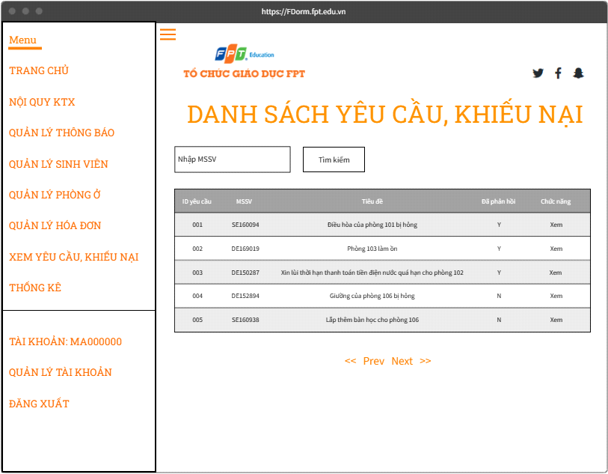

|  |  |  |  |
| --- | --- | --- | --- |
| **Screen** | View request and complaints | | |
| **Description** | View request and complaints from students | | |
| **Screen Access** | Manager click **“Xem yêu cầu, khiếu nại”** | | |
| **Screen Content** | | | |
| **Item** | **Type** | **Data** | **Description** |
| Nhập ID phòng | Search Box |  | Input box for Room ID for searching |
| Tìm kiếm | Button |  | Search button |
| ID yêu cầu | Label - Integer |  | Show request ID |
| MSSV | Label – String (8) |  | Display the student ID of the requester |
| Tiêu đề | Label – String (100) |  | Show the title of the request |
| Đã phản hồi? | Label – String (1) |  | Show the response status of the request |
| Chức năng | Label – String (20) |  | Show actions for manager |
| Xem | Link |  | When the user clicks on **Xem** in any line, the page allows viewing and responding to the request/complaint of the request in that line. |
| Paging | Link |  | Allow paging if website has giant database. |
| **Screen Actions** | | | |
| **Action Name** | **Description** | **Success** | **Failure** |
| Xem | When the user clicks on View, the system switches to the View page and responds to a request/complaint. | The screen shows the View and respond to a request/complaint page. | When there is a database connection error => Display the message "Lỗi kết nối cơ sở dữ liệu”. |
| Tìm kiếm | When the user clicks on Search, the system will perform a room search query according to the data entered by the user in the Enter MSSV box. | If the user does not enter anything in the Search box, the system will display all requests and complaints.  On the contrary, display the search results in the table of requests and complaints. | When there is a database connection error => Show message “Lỗi kết nối cơ sở dữ liệu”  When the value of a cell exceeds the maximum input limit => Display message “Vượt giới hạn ký tự tối đa!”.  When the system does not find any request or complaint, a message will be displayed “Không tìm thấy”. |
| Paging | When there are less than or equal to 10 fields, there is no pagination  When there are more than 10 data fields, show pagination  Clicking on Prev/Next will go to the next/next page from the current page if there is still a previous/next page. Click the <</>> button to go to the first/last page. | Navigate to required page. | When there is a database connection error => Display the message "Lỗi kết nối cơ sở dữ liệu”. |

* ***View and respond to a specific request/complaint***

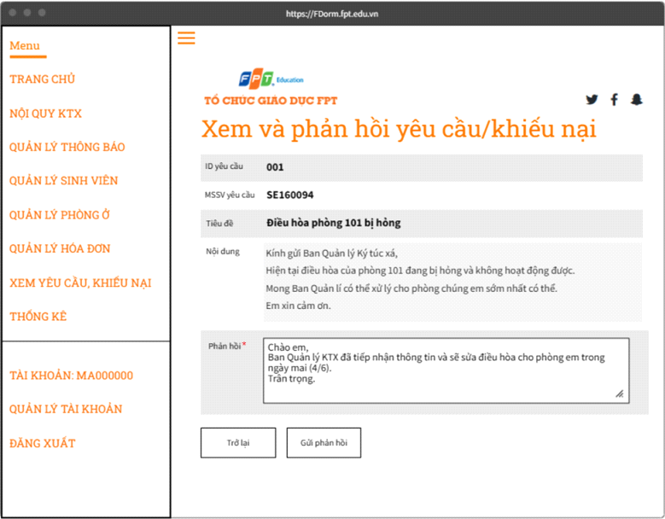

|  |  |  |  |
| --- | --- | --- | --- |
| **Screen** | View and respond to a specific request/complaint | | |
| **Description** | View and respond to a specific request/complaint from student | | |
| **Screen Access** | Manager click “**Xem yêu cầu, khiếu nại”** on the left banner **=>** click link **“Xem”** nearby each request/complaint. | | |
| **Screen Content** | | | |
| **Item** | **Type** | **Data** | **Description** |
| ID yêu cầu | Label – Integer |  | Request/complaint ID currently viewing |
| MSSV yêu cầu | Label – String (8) |  | Student ID number of requester |
| Tiêu đề | Label – String (100) |  | Title of the request |
| Nội dung | Label – String (1000) |  | Contents of the request |
| Phản hồi | Text field – String (1000) |  | Response input box for request |
| Trở lại | Button |  | Return to View requests and complaints |
| Gửi phản hồi | Button |  | Give feedback to students |
| **Screen Actions** | | | |
| **Action Name** | **Description** | **Success** | **Failure** |
| Trở lại | When the user clicks **Trở lại**, the system will go to the previous screen | Navigate to the previous screen | When there is a database connection error => Show message “Lỗi kết nối cơ sở dữ liệu” |
| Phản hồi | When the user clicks **Phản hồi**  , the system checks the validity of the data. | Mark the request as “Đã phản hồi”.  Return to the View and respond to requests/complaints screen and display a message “Phản hồi thành công” | When no feedback has been entered => The system will notify “Bạn chưa nhập nội dung phản hồi”  When the value of a cell exceeds the maximum input limit => Display message “Vượt giới hạn ký tự tối đa!”.  Khi có lỗi kết nối cơ sở dữ liệu => Hiển thị thông báo “Lỗi kết nối cơ sở dữ liệu” |

* ***Statisitcs***

|  |  |
| --- | --- |
| Use Case Name | Statistics |
| Use Case ID | UC17 |
| High Level Requirement Ref | Allow Manager to view the statistics of the dormitory. |
| Actor | Manager |
| Description | Re-statistical information of the dormitory with information queried from the database and displayed on the screen. Manager can view these statistics. |
| Trigger | N/A |
| Pre-condition | Manager click **“Thống kê”** on the left banner |
| Post-processing |  |

* ***View statistics***

|  |  |  |  |
| --- | --- | --- | --- |
| **Screen** | View stattistics | | |
| **Description** | Show dormitory’s statistics | | |
| **Screen Access** | Manager click “**Thống kê**” | | |
| **Screen Content** | | | |
| **Item** | **Type** | **Data** | **Description** |
| Tổng số chỗ | Label – Integer |  | View total slot of students in dormitory. |
| Số chỗ hiện đã ở | Label – Integer |  | View slot that is filled in dormitory |
| Số chỗ còn trống | Label - Integer |  | View available slot in dormitory |
| Số nam đang ở | Label - Integer |  | View the number of male students in dormitory |
| Số nữ đang ở | Label - Integer |  | View the number of female students in dormitory |
| Tổng số phòng | Label - Integer |  | View total number of rooms in dormitory |
| Số phòng đầy chỗ | Label - Integer |  | View number of rooms that are full in dormitory |
| Số phòng có người ở | Label - Integer |  | View number of rooms that have people living inside in dormitory |
| Số phòng trống | Label - Integer |  | View number of rooms that are available for booking in dormitory |
| Tổng số tiền đã trả | Label – Float |  | View total number of money earned from students in dormitory |
| Số tiền đã trả cho đăng ký phòng kì tới | Label – Float |  | View total number of money earned from students in dormitory for the next semester. |

* **NON-FUNCTIONAL REQUIREMENTS AND OTHERS**
* ***Performance***

|  |  |
| --- | --- |
| **No.** | **Requirement** |
| 1. | Allows a large amount of people access to the system through the internet |
| 2. | Response time no more than 5 seconds |
| 3. | Data import/export time is no more than 5 seconds |

* ***Scalability***

|  |  |
| --- | --- |
| **No.** | **Requirement** |
| 1. | Data storage capacity up to 1TB |
| 2. | Allows multiple users to perform the same operations at the same time |

* ***Security***

|  |  |
| --- | --- |
| **No.** | **Requirement** |
| 1. | Web Server using Xampp, using PHP > 8.0 |
| 2. | Requires login to perform functions corresponding to each user's role |
| 3. | User authentication with account and password |
| 4. | System data is backed up daily and stored securely off site |

* ***Browser***

|  |  |
| --- | --- |
| **No.** | **Requirement** |
| 1. | Chromium-based browsers (Google Chrome, Coc Coc, Microsoft Edge, ...) |
| 2. | Other browsers (Firefox, Safari, ...) |

* ***Reliability***

|  |  |
| --- | --- |
| **No.** | **Requirement** |
| 1. | If there is a problem, the system recovery time (from backed up data) is within 12 hours from the time the problem occurred. |

* ***Interfaces***

|  |  |
| --- | --- |
| **No.** | **Requirement** |
| 1. | Using Bootstrap 5 library, Jquery to create the interface. |

* ***Assumptions***

|  |  |
| --- | --- |
| **No.** | **Requirement** |
| 1. | The system can be suspended if an upgrade is required, but the suspension period should not exceed 12 hours. |